**White House Parks and Recreation**

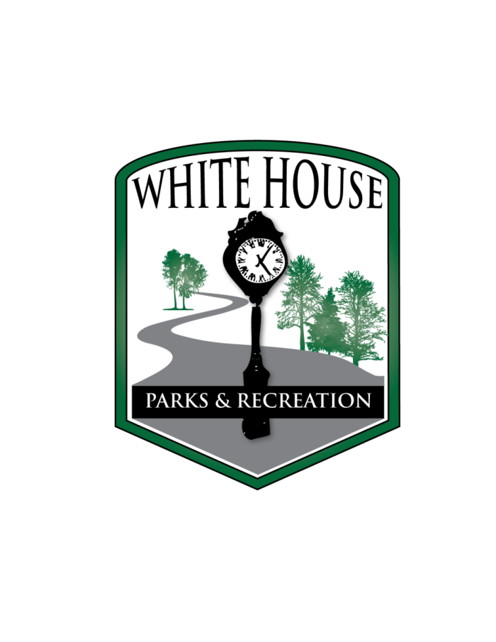

**Challenger Buddy Application**

Name Birth Date _____

SSN (*Background checks required for 18 & older.*): __________________________________

Address City State Zip

Home Phone ___________ Cell Phone ___________________________

Email __ Shirt Size: _______________________

Please list the Player’s name that you would like to be a Buddy for:

Player’s Full Legal Name

**Parent Information (if volunteer is under 18)**

Name

Address City State Zip

Home Phone ___________ Cell Phone ___________________________

Email ___________

**Will any child related to you be registered as a player in the league?** **Yes** **No**

If so, please complete the following information:

Child’s Full Legal Name

**Hold Harmless Agreement**

I/We agree to indemnify and save harmless the City of White House, it’s officers, agents and employees from and against all loss or expense (including attorney fees) by reason of liability imposed by law upon the City of White House for damages due to bodily injury, including loss of thereof, arising out of or in consequence of the performance of this agreement, providing such injury to persons or damage to property is due or claimed to be due to the negligence of the above named participant, its officers, employees, or agents. A copy of this authorization shall be effective as the original.

X

Signature of Volunteer Date

X

Signature of Parent Date