**Memo**

To: City of White House Planning Commissioners

From: Ceagus Clark, Director of Planning & Codes

Date: 9/6/2023

Re: Cover Page for the Planning Commission Staff Notes; meeting scheduled 9/11/2023

There are seven items on the agenda:

Item # 1 Fields at Oakwood-Phase 2.2: Requests a one-year bond extension.

Item # 2 Summerlin-Phase 3: Requests a one-year bond extension.

Item # 3 Concord Springs-Phase 2B/Real Estate Solutions Group, LLC: Requests bond reduction.

Item # 4 Concord Springs-Phase 3/Real Estate Solutions Group, LLC: Requests bond reduction.

Item # 5 Gregory Pierce Subdivision

Item # 6 Cardinal Pointe Development/CSDG: Requests Final Plat Approval

Item # 7 Staff: Requests Recommendation to the Board of Mayor and Aldermen to accept Concord Springs-Phase 1.

I’ve also enclosed the by-laws and Chapter 4 of the Tennessee Annotated Code, which govern Municipal Planning Commissions.

Don’t hesitate to give me a call.

615-672-4350 Ext 2119

Ceagus Clark

Director, Planning and Codes

**Item # 1: Fields at Oakwood-Phase 2.2: Requests a one-year bond extension**

**Staff Overview**

Requests a one-year bond extension. Bond is for the coverage of street lights, stormwater, wastewater, sidewalk construction and asphalt costs.

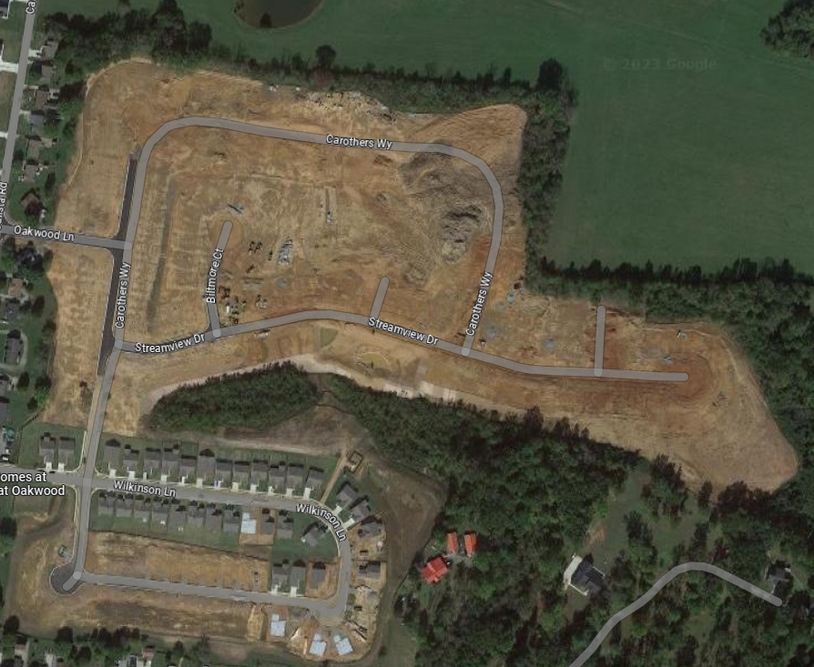

**3-101.2 Surety Instrument**

Moreover, whenever such bond or letter of credit is extended according to these regulations, the price of completing all bondable improvements must be reanalyzed and established by the City Planning Commission in order that the surety instrument be adequate to cover the cost of all improvements.

Applicant or Representative-Overview:

**Ryan Homes**

Overview:

**Current Bond:**

**$244,023.00**

Tax Parcel and ID

**NA**

Zoning

**SRPUD**

Ordinance Reference and Notes: **3-101.2**

**Finding of Fact:**

Surety Increase to: **$280,626.**

The developer has not yet requested a deduction. The approved 15% increase to bond has been applied.

**Item # 4: Raymond Hirsh**

**Item # 2: Summerlin-Phase 3: Requests a one-year bond extension**

**Staff Overview**

Requests a one-year bond extension. Bond is for the coverage of street lights, stormwater, wastewater, sidewalk construction and asphalt costs.

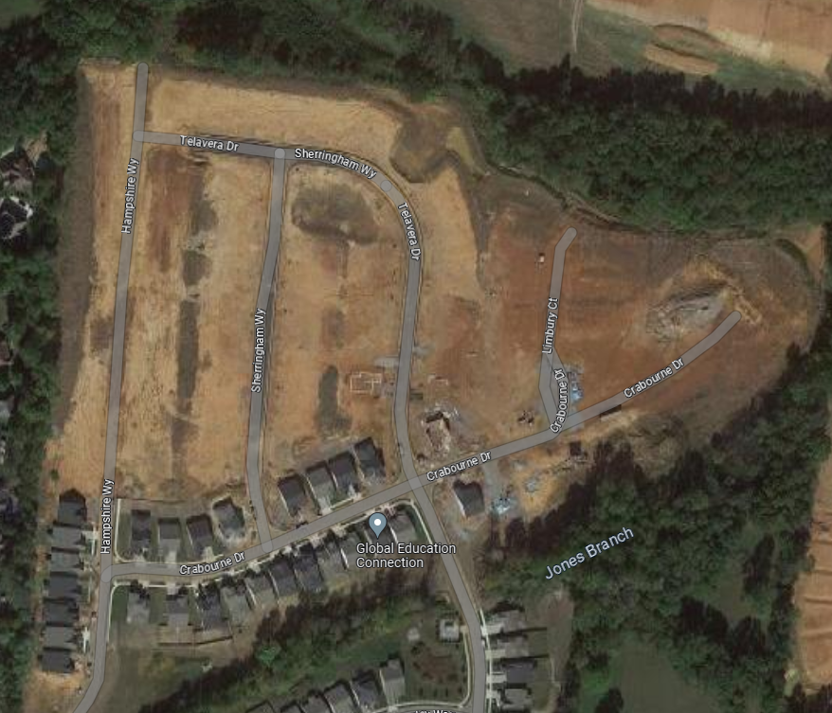

**3-101.2 Surety Instrument**

Moreover, whenever such bond or letter of credit is extended according to these regulations, the price of completing all bondable improvements must be reanalyzed and established by the City Planning Commission in order that the surety instrument be adequate to cover the cost of all improvements.

Applicant or Representative-Overview:

**Goodall Homes**

Overview:

**Current Bond:**

**$173,199**

Tax Parcel and ID

**NA**

Zoning

**SRPUD**

Ordinance Reference and Notes: **3-101.2**

**Finding of Fact:**

Surety Increase to: **$199,179.**

The developer has not yet requested a deduction. The approved 15% increase to bond has been applied.

**Item # 4: Raymond Hirsh**

**Item # 3 Concord Springs-Ph 2B: Requests bond reduction**

Applicant or Representative-

**Real Estate Solutions Group, LLC**

Overview:

**Current Bond:**

**$247,641**

Tax Parcel and ID

**NA**

Zoning

**SRPUD**

Ordinance Reference and Notes: **3-101.2**

**Finding of Fact:**

Public Works has inspected the applicants request to reduce the bond from $247,641 to $_______. This is consistent with reasons to approve this request.

**Staff Overview**

Requests a bond reduction. Bond is for the coverage of street lights, stormwater, wastewater, sidewalk construction and asphalt costs.

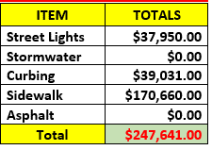

**3-101.2 Surety Instrument**

Moreover, whenever such bond or letter of credit is extended according to these regulations, the price of completing all bondable improvements must be reanalyzed and established by the City Planning Commission in order that the surety instrument be adequate to cover the cost of all improvements.

**Item # 4: Concord Springs-Ph 3: Requests bond reduction**

**Staff Overview**

Requests a bond reduction. Bond is for the coverage of street lights, stormwater, wastewater, sidewalk construction and asphalt costs.

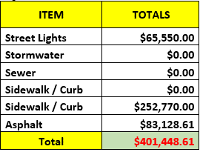

**3-101.2 Surety Instrument**

Moreover, whenever such bond or letter of credit is extended according to these regulations, the price of completing all bondable improvements must be reanalyzed and established by the City Planning Commission in order that the surety instrument be adequate to cover the cost of all improvements.

Applicant or Representative-Overview:

**Real Estate Solutions Group, LLC**

Overview:

**Current Bond:**

**$401,449**

Tax Parcel and ID

**NA**

Zoning

**SRPUD**

Ordinance Reference and Notes: **3-101.2**

**Finding of Fact:**

Public Works has inspected the applicants request to reduce the bond from $401,449 to $_______. This is consistent with reasons to approve this request.

**Item # 4: Raymond Hirsh Parkway Commercial**

**Item # 5: Gregory Pierce- Subdivision:**

Proposed subdivision:

Existing lot:

**Staff Overview**

Requests to subdivide one lot into four lots. The division will create two new lots to be built on, and will reduce the size of the existing house lot. The property consists of 1.95 acres. Lot four will be a quit claim deed to the Gant family, in which they will combine the rear portion of lot four (their existing lot). Lot three will be for the existing home of Mr. Pierce. Lot one will be a new lot, with access from Kennedy Dr, and Lot two will be a new lot, with access from Hillwood Dr. The two new lots will be over 20,000.

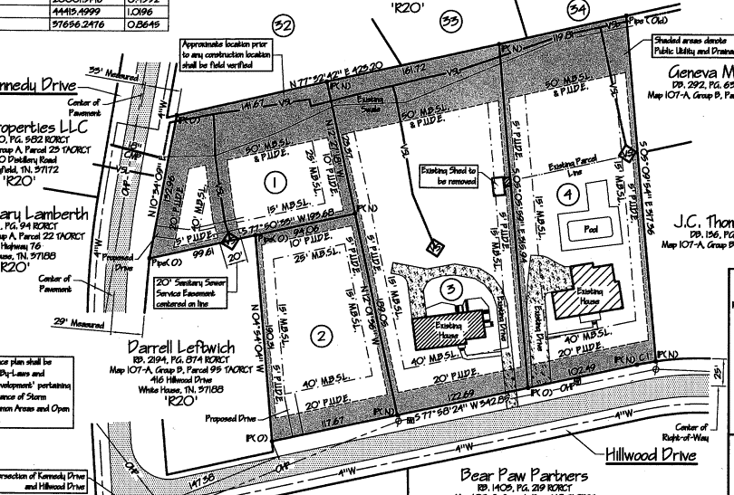

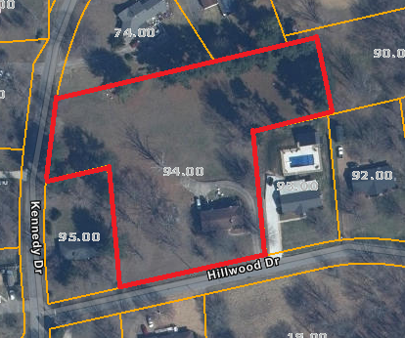

Applicant or Representative-Overview:

**Gregory Pierce**

Tax Parcel and ID

**Robertson County Tax Map 107A, Group B 094.00**

Zoning

**R-20**

Ordinance Reference and Notes:

**Finding of Fact:**

Each lot would still be over 20,000 square feet, which meets the requirement for R-20 zoning.

**Item # 4: Raymond Hirsh**

**Item # 6: Cardinal Pointe Development/CSDG: Requests Final Plat Approval:**

**Staff Overview**

Requests Final Plat Approval to dedicate right-of-way for the extension of Madeline Way as well as public utility easements associated with the approved Cardinal Pointe Development.

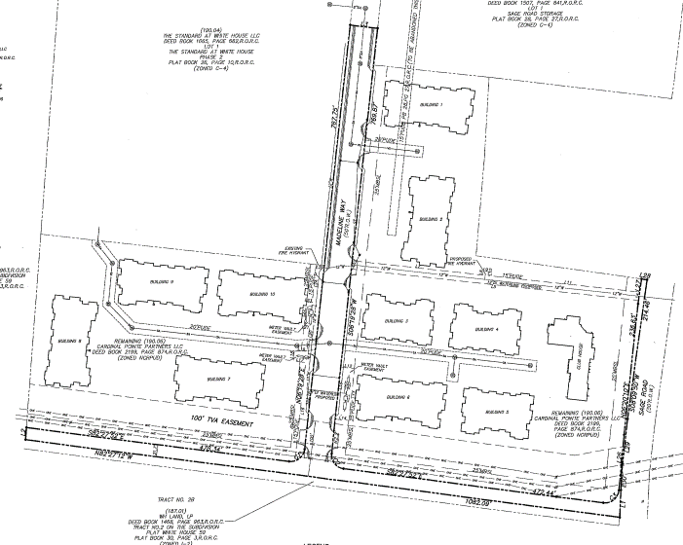

Applicant or Representative-Overview:

**Cardinal Pointe Partners, LLC**

Overview:

**Requests Final Plat**

Tax Parcel and ID

**Robertson County Tax Map 106 and Part of Parcel 190.06**

Zoning

**NCRPUD**

Ordinance Reference and Notes:

**Finding of Fact:**

Approval based on the plat is consistent with the approved Final Master Development Plan

**Item # 7: Staff: Requests Recommendation to BOMA to accept Concord Springs-Phase 1**

**Staff Overview**

This is a request to accept the road/infrastructure for Concord Springs located on Calista Rd. There was a $34,500 Maintenance bond held for improvements to be made, which expires at the end of this month.

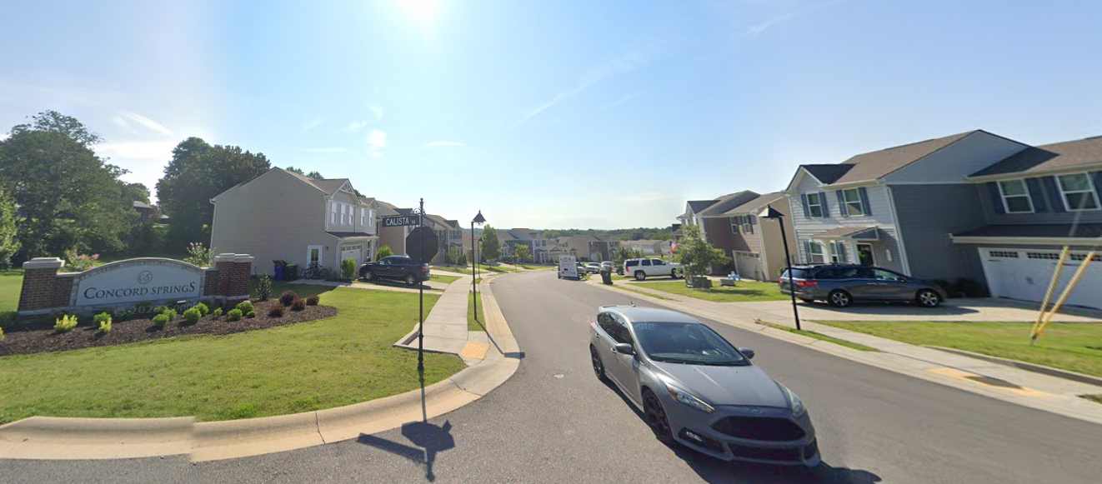

**3-101.7 Acceptance of Dedication Offers**

Acceptance of formal offers of dedication of public ways, easements, and parks shall be by formal action of the governing body or other agency ultimately responsible for acceptance of the facilities. Such action shall be in the form of a resolution recommended by the Planning Commission to the accepting body. The approval by the Planning Commission of a subdivision plat shall not be deemed to constitute or imply an acceptance by the local government or other agency ultimately responsible for acceptance of the facilities of any public way, easement, or other ground shown on the plat. The Planning Commission may require the plat to be endorsed with appropriate notes to this effect.

Applicant or Representative-Overview:

**Staff**

Current bond amount:

**34,500.00**

Tax Parcel and ID

**NA**

Zoning

**SRPUD**

Location Overview:

**Calista Road**

**Finding of Fact:**

Public Services has inspected the work needed to be done and is recommending the city accept the remainder of road and stormwater infrastructure.

**2-104.3 Hearing and Decision on Final Plat**

The Planning Commission shall hold a hearing as required by Section 13-3-404 and 13-4-304, Tennessee Code, on each final plat brought before it. The Planning Commission shall, within thirty (30) days, or sixty (60) days as appropriate after submission of the plat, approve, modify, or disapprove the final subdivision plat by resolution, which shall set forth in detail any conditions to which the approval is subject, or reasons for disapproval.

Failure of the Planning Commission to act upon a plat within the prescribed time shall be deemed approval of the plat, and in such event, a certificate of approval, entitling the subdivider to proceed as specified in Subsection 2-104.4 and Section 2-105, of these regulations, shall be issued, upon demand, by the secretary of the Planning Commission. The applicant, however, may agree to an extension of the time for Planning Commission review.

One (1) copy of the final subdivision plat shall be returned to the subdivider with the date of approval, conditional approval, or disapproval noted thereon.

13-4-304. Procedure on submission of plats — Approval or disapproval — Contents — Hearings — Procedure in certain counties.

**(a)** The commission shall approve or disapprove a plat within sixty (60) days after the initial consideration of the plat by the commission meeting in a regularly scheduled session, unless at the end of the sixty-day period there is a holiday or an unexpected interceding event that would close municipal or county offices and thus affect the normal computation of the sixty-day period, in which case the plat shall be approved or disapproved after the interrupted sixty-day period at the next regularly scheduled meeting of the commission; otherwise, the plat shall be deemed approved and a certificate to that effect shall be issued by the commission on demand. The applicant for the commission's approval may waive the time requirement set in this subsection (a) and consent to an extension or extensions of the applicable time period. When a plat has been filed with the appropriate officials of the planning commission, the plat shall be placed on the agenda of the planning commission within thirty (30) days of the filing or the next regularly scheduled planning commission meeting after the thirty-day period. The applicant may waive the time frame requirement for the appearance of the plat on the agenda.

**(b)** The ground of disapproval of any plat shall be stated upon the records of the commission.

**(c)** Any plat submitted to the commission shall contain the name and address of a person to whom notice of hearing shall be sent; and no plat shall be acted upon by the commission without affording a hearing thereon, notice of the time and place of which shall be sent by mail to such address not less than five (5) days before the date fixed for such hearing.

**(d)** In counties having populations not less than three hundred twenty-five thousand (325,000) nor more than four hundred thousand (400,000), according to the 1990 federal census or any subsequent federal census, in the event the municipal planning commission approves or disapproves a plat after a hearing thereon, the applicant submitting the plat or any person who was a party for or against the plat request at the planning commission hearing shall have the right within thirty (30) days after such approval or disapproval to have the action of the municipal planning commission reviewed by the chief legislative body of the municipality having jurisdiction over zoning matters, who shall by majority vote approve or disapprove the plat. If the plat is approved, the secretary of the regional planning commission shall endorse the plat for recording as prescribed in § 13-3-402. No such plat shall be recorded until after the county court or other legislative body has acted on a request for a review of the action of the planning commission if there is a request within thirty (30) days.