**Memo**

To: City of White House Planning Commissioners

From: Ceagus Clark, Director of Planning & Codes

Date: 6/30/2023

Re: Cover Page for the Planning Commission Staff Notes; meeting scheduled 7/10/2023

There are eight items on the agenda:

* + Copes Crossing-Phase 1A: Requests a one-year bond extension.
  + Fields at Oakwood-Phase 3 & Phase 4.1: Requests a one-year bond extension.
  + Summerlin-Phase 7-: Requests a one-year bond extension
  + Raymond Hirsch Parkway Commercial PUD/Kimley-Horn: Rezoning Request R-20-CPUD
  + Summerlin Subdivision-Phase 9/Dewey Engineering: Final Plat Approval
  + Drew Christenson Development/Green LID Design: Final Plat Approval
  + The Smile Center/GreenLID Design: Site Plan Approval

Don’t hesitate to give me a call.

615-672-4350 Ext 2119

Ceagus Clark

Director, Planning and Codes

**Item #1: Copes Crossing-Phase 1A:**

**Staff Overview**

**Copes Crossing-Phase 1A is currently under construction.**

|  |  |
| --- | --- |
| **ITEM** | **TOTALS** |
| **Street Lights** | **$7,856.00** |
| **Stormwater** | **$80,825.00** |
| **Sewer** | **$104,800.00** |
| **Sidewalk / Curb** | **$156,340.00** |
| **Asphalt** | **$30,068.50** |
| **Landscape** | **$0.00** |
| **Total** | **$379,889.50** |

**3-101.2 Surety Instrument**

Moreover, whenever such bond or letter of credit is extended according to these regulations, the price of completing all bondable improvements must be reanalyzed and established by the City Planning Commission in order that the surety instrument be adequate to cover the cost of all improvements.

Applicant or Representative-

**Pulte Homes**

Overview:

**Current Bond:**

**$379,890**

Tax Parcel and ID

**NA**

Zoning

**SRPUD**

Ordinance Reference and Notes: **3-101.2**

**Project Area Description**

Copes Crossing began construction in the Summer of 2022**.**

**Finding of Fact:** Surety Increase to: **$436,874**

The developer has not yet requested a deduction. The approved 15% increase to bond has been applied.

**Item # 2: Fields at Oakwood-Phase 3 & Phase 4.1:**

**Staff Overview**

Requests a one-year bond extension

|  |
| --- |
| **ITEM** |
| **Street Lights** |
| **Sidewalk / Curb** |
| **Asphalt** |
| **Sewer** |
| **Stormwater** |
| **Total $140,620** |

Public Services approved a reduction to $140,620 in 2022 to give credit for completed improvements.

**3-101.2 Surety Instrument**

Moreover, whenever such bond or letter of credit is extended according to these regulations, the price of completing all bondable improvements must be reanalyzed and established by the City Planning Commission in order that the surety instrument be adequate to cover the cost of all improvements.

Applicant or Representative-

**Ryan Homes**

Overview:

**Current Bond:**

**$140,620**

Tax Parcel and ID

**NA**

Zoning

**SRPUD**

Ordinance Reference and Notes: **3-101.2**

**Project Area Description**

This phase has 19 lots and began construction in the Fall of 2022.

**Finding of Fact:** Surety Increase to: **$161,713**

The developer has not yet requested a deduction. The approved 15% increase to bond has been applied.

**Item # 3: Summerlin-Phase 7: 7:**

**Staff Overview**

Requests a one-year bond extension

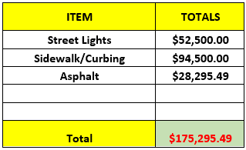

**3-101.2 Surety Instrument**

Moreover, whenever such bond or letter of credit is extended according to these regulations, the price of completing all bondable improvements must be reanalyzed and established by the City Planning Commission in order that the surety instrument be adequate to cover the cost of all improvements.

Applicant or Representative-Overview: **Goodall Homes**

Tax Parcel and ID

**NA**

Zoning and Property

SRPUD- **Suburban Residential Planned Unit Development**

Ordinance Reference and Notes: **3-101.2**

**Finding of Fact:**

Surety Increase to: **$175,295.49**

The developer has not yet requested a deduction. The approved 15% increase to bond has been applied.

**Item # 4: Raymond Hirsh Parkway Commercial PUD/Kimley-Horn**

**Staff Overview**

Request to rezone 22.83 acres from R-20, Low Density Residential to CPUD, Commercial Planned Unit Development. Applicant is also requesting for Preliminary Plan Approval for a mixed-use development. This would consist of commercial and residential uses. This proposed development two lots with multifamily space with 70 units, consisting of alley loaded garage entry, 8 lots with about 52,000 square feet of commercial retail and office space.

In the following pages, you will find information from the zoning ordinance regarding the Commercial PUD and language from the comprehensive plan to help with your review.

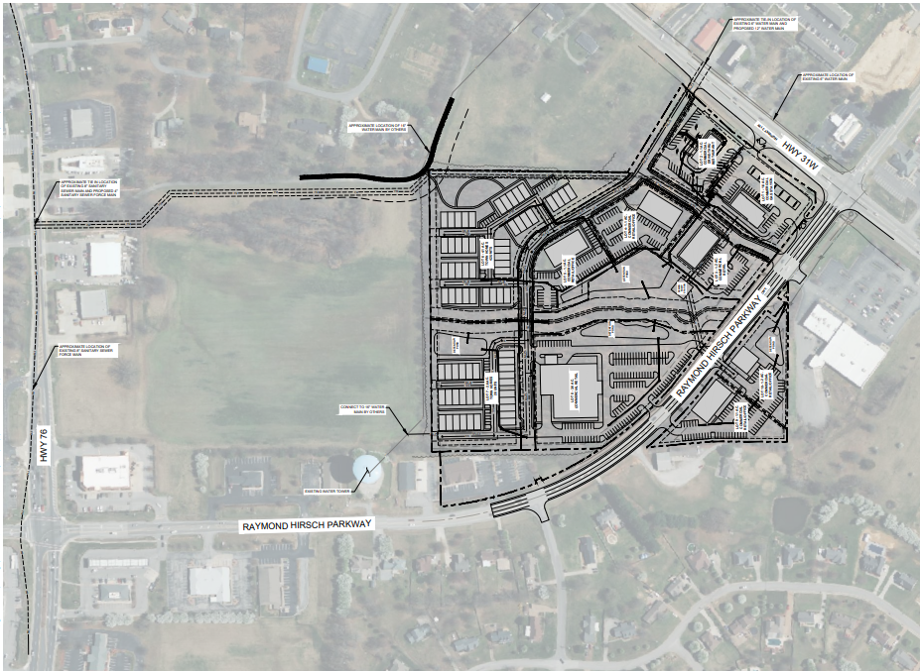

Applicant or Representative-Overview: **Patricia Jones and Shrihari, LLC**

Tax Parcel and ID

**Robertson County Tax Map 107I, Parcels 75, 76, and 77**

Location:

**Raymond Hirsch Parkway and Highway 31W**

Zoning

**R-20**

Comprehensive Plan District:

**Mixed Use and White House Crossroads**

**Finding of Fact:**

Based on the Comprehensive Plan, rezoning to CPUD would be appropriate

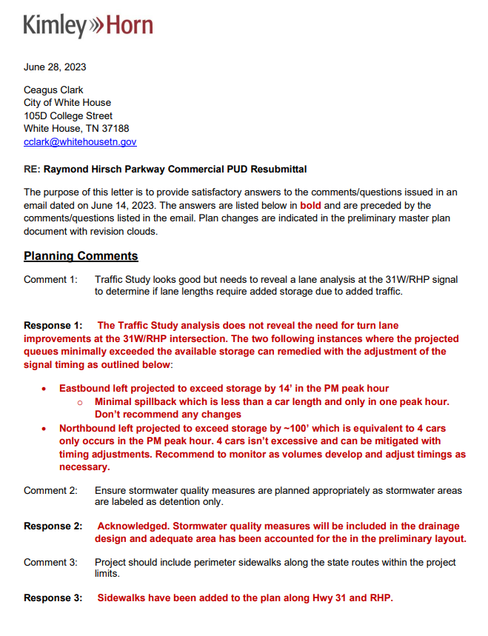

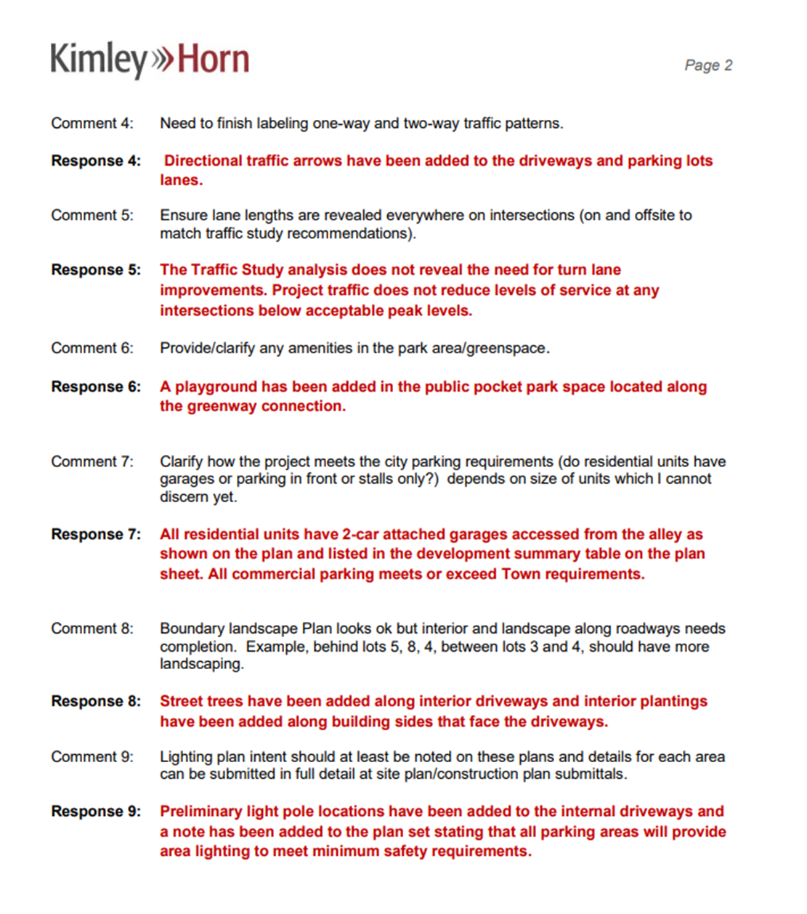

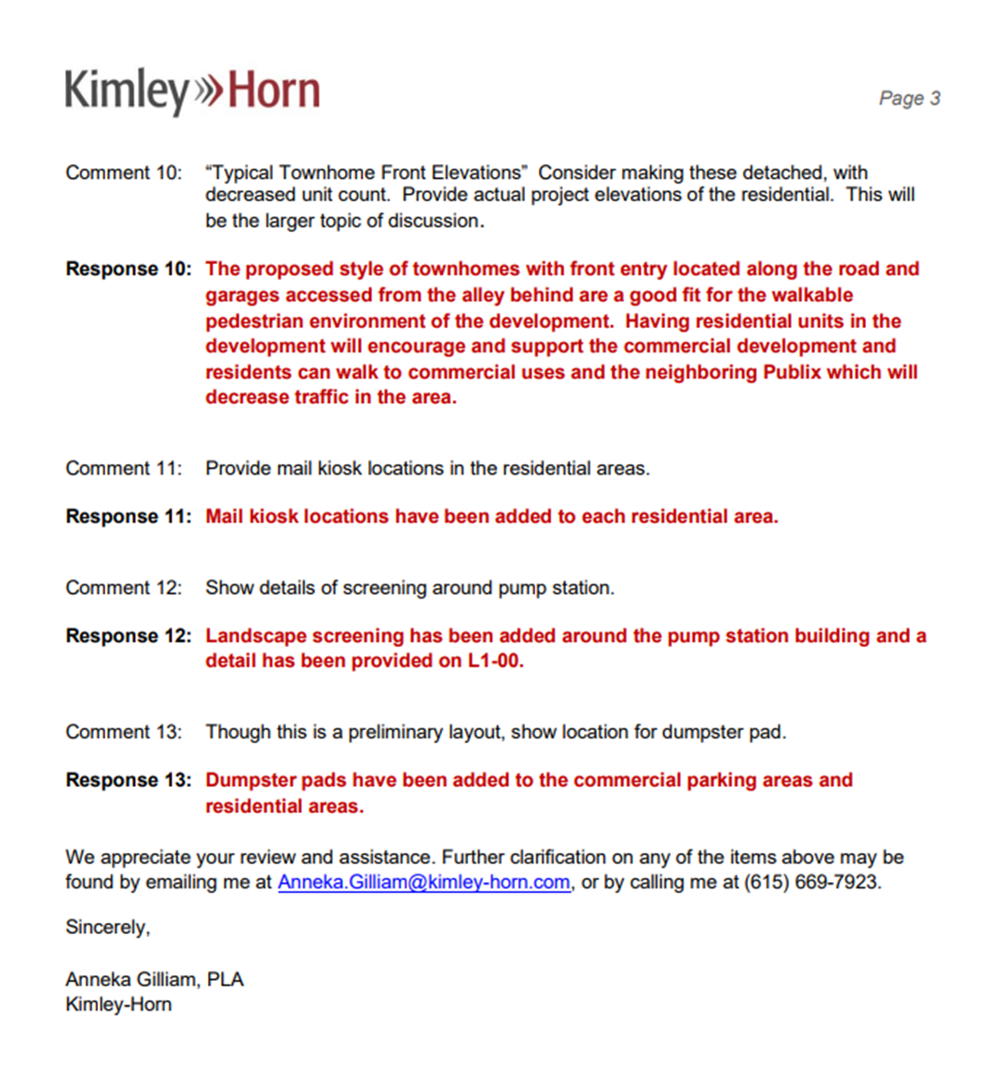

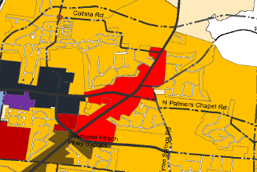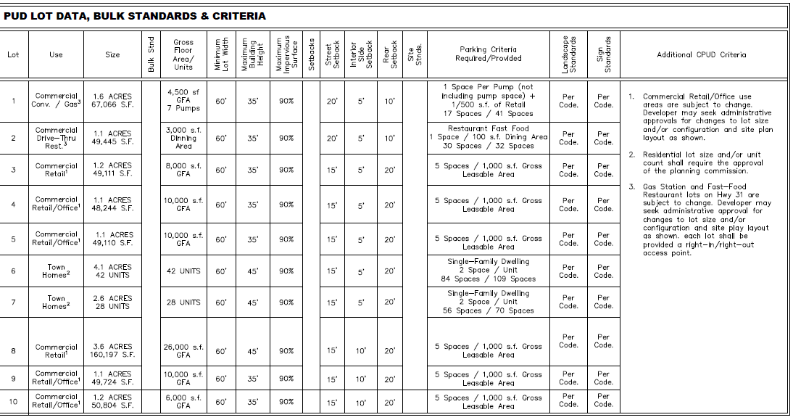

The Comprehensive Plan Map shows this area as being in the ‘White House Crossroads’ and ‘Mixed Use’ areas. The White House Crossroads description of appropriate zoning is C-1 Central Business, C-6 Town Center Commercial, R-TC High Density Town Center Commercial, and NC-PUD Neighborhood Center Planned Unit Development. The White House Crossroads Character Area is characterized by a compatible mixture of commercial, civic, and residential uses that help form the most urban center of the community. The Neighborhood Mixed Use Character Area is characterized by a mix of residential, small-scale commercial, and low-impact office uses. The appropriate zoning for Mixed Use is C-1 Central Business, C-2 General Commercial, C-4 Office/Professional, SR-PUD Suburban Planned Unit Development, NC-PUD Neighborhood Center Planned Unit Development. R-10 High-Density Residential is appropriate only for small scale properties of 1-3 acres.

5.056.6 **Commercial Planned Developments**

A. Type of Developments

There are hereby created four (4) types of commercial planned unit developments as follows:

Commercial Planned Unit Development CPUD

Commercial Planed Unit Development Limited CPUDL

General Office Planned Unit Development GOPUD

Restricted Office Planned Unit Development ROPUD

B. Purpose

The general purpose of Commercial PUD Districts is to provide for a wide range of activities developed for high quality and under controlled conditions.

C. Feasibility Study

The planning commission and/or the board of mayor and aldermen may require a feasibility study/market analysis for any proposed commercial planned unit development. The study will be utilized, among other things, to determine the impact of the proposed development on the long-range development of the commercial land use in the city, the timing of any proposed development to ascertain the effects of a proposed development upon lands used or zoned for commercial purposes, to form a basis for evaluating the estimated effects on traffic, the financial capability of the developer, and other purposes which assist in an understanding of the public interest pertinent in the evaluation of a proposed development. The study, if required, shall be provided by the landowner and the landowner shall provide any other economic data or analysis as may be reasonably requested by the planning commission and/or board of mayor and aldermen.

D. Minimum Size

The minimum size for each type Commercial PUD shall be as follows:

CPUD 5 acres

CPUDL No minimum

GOPUD 5 acres

ROPUD 1 acre

E. Permitted Activities

The activities listed in Table II, may be permitted as a part of PUD only when such activities are approved as a part of the final master plan and deemed appropriate by the planning commission. A change in use may be granted by the building inspector, only when the change is to a similar use or activity. Activities not listed are prohibited.

F. Bulk Regulations for Commercial PUDs

The building intensity, height, and open space requirements shall be as follows:

1. Maximum Floor Area Ratio

CPUD 1.0

CPUDL 5

GOPUD 1.5

ROPUD 25

2. Maximum Building Height: No building shall exceed thirty-five feet in height, except as provided in Article VII, Section 7.040. **(Amended by Ordinance 03-10, August 21, 2003)**

3. Open Space Requirements

The following building setbacks and open space requirements shall be observed:

Front

CPUD 60 feet

CPUDL 40 feet

GOPUD 50 feet

ROPUD 40 feet

Side and Rear

CPUD 30 feet

CPUDL 20 feet

GOPUD 15 feet

ROPUD 15 feet

For a building in excess of two (2) stories, the side and rear yard requirement shall be increased five (5) feet for each story in excess of two (2) stories

**Table II**

**Permitted Uses and Structures Within**

**Commercial Planned Unit Development Districts**

CPUD CPUDL GOPUD ROPUD

Community Facility Activities

Administrative Services P P P P

Community Assembly P P P N

Community Education N N N N

Cultural & Recreation Services P N P N

Essential Services P P P P

Extensive Impact Facilities N N N N

Health Care Facilities P N P N

Institutional Care Facilities N N N N

Intermediate Impact Facilities N N N N

Personal & Group Care Facilities P N P N

Religious Facilities

Commercial Activities

Animal Care & Veterinarian Services N N N N

Automotive Parking P P P P

Automotive Repair & Cleaning N N N N

Automotive Servicing P N N N

Building Materials & Farm Equipment N N N N

Consumer Repair Services P P P P

Construction Sales & Services N N N N

Convenience Commercial P P P P

Entertainment & Amusement Services P P N N

Financial, Consultive & Administrative P P P P

Food & Beverage Services P P P P

Food Service Drive-In P P N N

General Business & Communication Service P P P N

General Personal Services P P P P

General Retail Trade P P P P

Group Assembly P N N N

Medical & Professional Services P P P P

Scrap Operations N N N N

Transient Habitation P N P N

Transport & Warehousing N N N N

Undertaking Services P N N N

Vehicular, Craft, & Related Equipment

Sales, Retail & Delivery P P P N

Wholesale Sales P N P N

Key to Interpreting Uses

P - May be Considered In the District Indicated

N - Not Permitted In the District

Provided further that permanent open, landscaped areas meeting the requirements of Article III, Section 3.120, shall be maintained. No buildings or parking areas shall be permitted in any required permanent open space.

G. Off-street Parking, Loading, and Vehicular Access

1. Off-street parking and loading space shall be provided in accordance with the provisions for off-street parking contained in Article IV. Parking lot landscaping shall be provided in accordance with the landscaping provisions of Chapter IV, Section 4.010 and 4.020.

2. Vehicular Access Locations

Vehicular access locations shall be provided so that vehicles entering or departing a commercial planned unit development site shall do so only at such locations. Elsewhere along the property lines of said commercial planned unit developments site a physical separation between the said site and public rights-of-way shall be provided. A vehicular access location shall consist of such entrance and exit driveway openings so designed and located so as to minimize hazardous vehicular turning movements and traffic congestion. Such design and location shall be subject to the approval of the City Engineer working in conjunction with the Planning Commission.

a. No vehicular access location serving a commercial planned unit development site shall be:

(1) Within twenty-five (25) feet of the intersection of street right-of-way lines, bounding, in part, the same commercial planned unit development site, and

(2) Within one hundred (150) feet of any interchange ramp. Such distance shall be measured from a point where the center line of the ramp intersects with the edge of the pavement of the travel way of the intersecting street.

H. Permitted Signs

Signs may be permitted in accordance with the provisions of the White House Zoning Ordinance. Sign locations and character shall be approved as a part of the final master plan.

**Item # 5 Summerlin Subdivision-Phase 9/Dewey Engineering:**

**Staff Overview**

Requests Final Plat approval for 12.9 acres consisting of 35 single family lots. This is the final phase of the Summerlin Subdivision

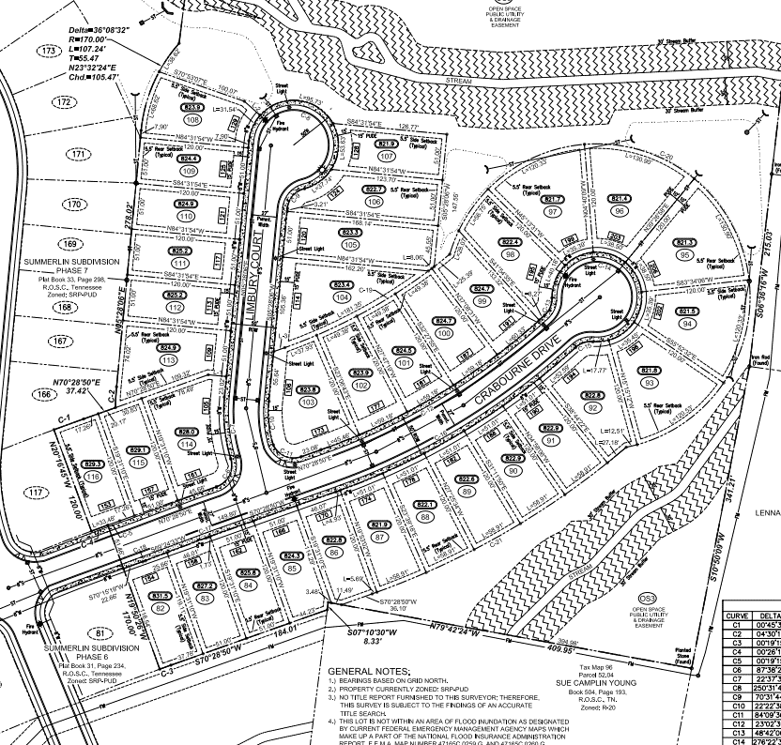

Applicant or Representative-Overview: **Clayton Properties Group, Inc**

Tax Parcel and ID

**Sumner County Tax Map 96, Parcel 55.00**

Location:

**McCurdy Road**

Zoning

**SRPUD**

**Finding of Fact:**

Construction Plans for this phase has been approved. The Final Plat is consistent with the FDMP

**Item # 6: Drew Christenson Development/Green LID Design**

**Staff Overview**

Requests Final Plat Approval for 14-single family units, and 4

Town-home units.

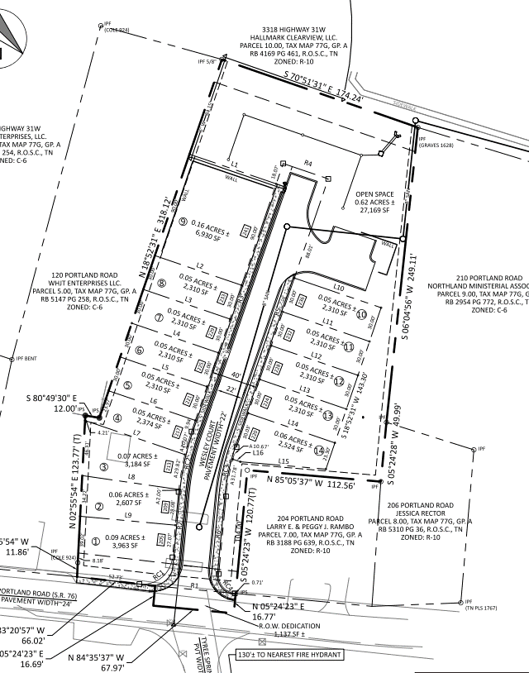

Applicant or Representative-Overview: **Drew Christenson**

Tax Parcel and ID

**Sumner County Tax Map 077G, Group A, Parcel 006.00**

Location:

**202 Portland Road**

Zoning

**C-6 Town Center Commercial**

**Finding of Fact:**

Construction Plans for these phases have been approved. The Final Plats are consistent with the preliminary plat.

**Item # 7: The Smile Center/GreenLID Design**

**Staff Overview**

Requests Site Plan approval for a proposed 5,000 square foot dental office building.

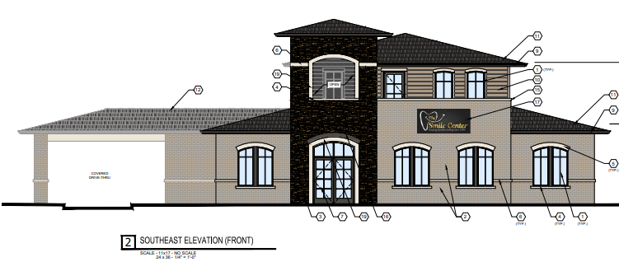

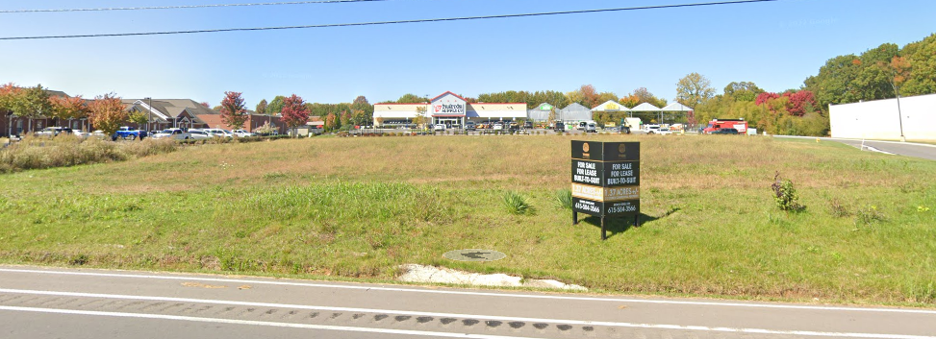

Applicant or Representative-Overview: **BT White House Associates, LLC**

Tax Parcel and ID

**Robertson County Tax Map 107I, Group B, Parcel 080.02**

Location:

**2901 Highway 31W**

Zoning

**C-2**

**Finding of Fact:**

By-Right Zoning. The site plan has met all criteria.

