**Memo**

To: City of White House Planning Commissioners

From: Ceagus Clark, Director of Planning & Code

Re: Cover Page for the Planning Commission Staff Notes; meeting scheduled 8/8/2022

**Item # 1 Concord Springs-Phase 1:** Requests bond extension.

**Item # 2 Summerlin-Phase 2:** Requests bond extension.

**Item # 3 Fields at Oakwood-Phase 1:** Requests bond extension.

**Item # 4 The Parks-Phase 3:** Requests bond reduction.

**Item # 5 Staff:** Requests Recommendation to add Industrial Overlay District

**Item # 6 Staff:** Requests Recommendation to amend C-2 General Commercial

**Item # 7 Cox’s Place/Gretchen Cox:** Request annexation recommendation

**~~Item # 8 Dorris Farm at Willow Springs-Ph 1, Sec 1:~~**~~Requests Final Plat Approval~~

**~~Item # 9 Dorris Farm at Willow Springs-Ph 1 Sec 2:~~** ~~Requests Final Plat Approval~~

**Item # 10 Summerlin-Ph 8:** Requests Final Plat Approval

**Item # 11 Copes Crossing-Ph 1A:** Requests Final Plat Approval

615-672-4350 Ext 2119

Ceagus Clark

Director, Planning and Codes

**Item # 1 Staff Notes- Concord Springs Phase 1**

**Staff Overview**

The developers requested a bond reduction to phase 1 in the Concord Springs Subdivision last August. Staff did an inspection on this phase and gave credit for all work done with the exception of the storm water facility. The current bond amount is $777,836. A reduction to $30,000 was been approved. This is a request to increase the bond 15%. The remainder of the bond will cover any stormwater maintenance until the city accepts the public infrastructure. There are only 5 units left to build in this development.

**3-101.2 Surety Instrument**

Moreover, whenever such bond or letter of credit is extended according to these regulations, the price of completing all bondable improvements must be reanalyzed and established by the City Planning Commission in order that the surety instrument be adequate to cover the cost of all improvements. Said estimate shall include an additional 15 (fifteen) percent over and above the cost of securing all necessary improvements to cover the rate of inflation over the bondable period. The performance bond or letter of credit shall also secure all lot improvements on the individual lots of the subdivision as required in these regulations.

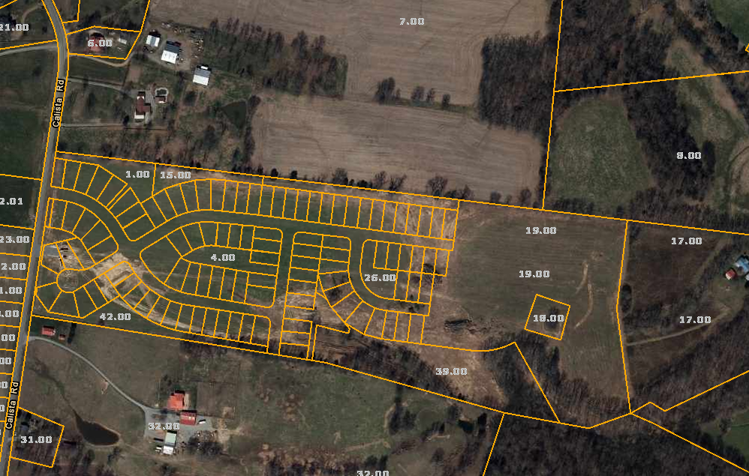

Applicant or Representative-Overview:

**Increased from $30,000 to $34,500**

Tax Parcel and ID

**NA**

Zoning

**SRPUD**

Ordinance Reference and Notes: **3-101.2**

**Findings of fact:** The development has not been fully accepted by the city. The increase is warranted.

**Item # 2 Summerlin-Phase 6: Bond Increase**

**Staff Overview**

This is a request for a one-year subdivision improvement. Staff did an inspection on this phase in January 2020. The repairs noted from the inspection have not been updated as of yet. There are 89 out of 299 units to be built.

**3-101.2 Surety Instrument**

Moreover, whenever such bond or letter of credit is extended according to these regulations, the price of completing all bondable improvements must be reanalyzed and established by the City Planning Commission in order that the surety instrument be adequate to cover the cost of all improvements.

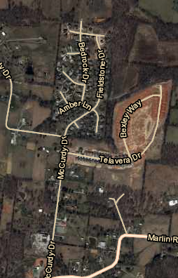

Applicant or Representative-Overview:

**One Year Bond Extension $105,613 to $121,455**

Tax Parcel and ID

**NA**

Zoning

**SRPUD**

Ordinance Reference and Notes: **3-101.2**

Project Area Description

**Phase 2 infrastructure within the Summerlin Subdivision. This includes the curve, sidewalks, streetlights, detention pond and storm grates.**

Finding of Fact: **No improvements have been made to infrastructure. Increase bond amount by 15%**

**Item # 3 Staff Notes- Fields at Oakwood Phase 1**

Applicant or Representative-Overview:

**One Year Bond Extension $296,629 to $341,123**

Tax Parcel and ID

**NA**

Zoning

**SRPUD**

Ordinance Reference and Notes: **3-101.2**

Project Area Description

**Phase 1 of Fields of Oakwood**

Finding of Fact: **No improvements have been made to infrastructure. Increase bond amount by 15%**

**Staff Overview**

This is a request for a one-year subdivision improvement. Staff did an inspection to see if the bond should be reduced and deemed the extension necessary. The developer is aware of this increase and has stated that he will check the progress of development and request an inspection of improvements made.

**185 out of 234 lot remaining to be built.**

**3-101.2 Surety Instrument**

Moreover, whenever such bond or letter of credit is extended according to these regulations, the price of completing all bondable improvements must be reanalyzed and established by the City Planning Commission in order that the surety instrument be adequate to cover the cost of all improvements.

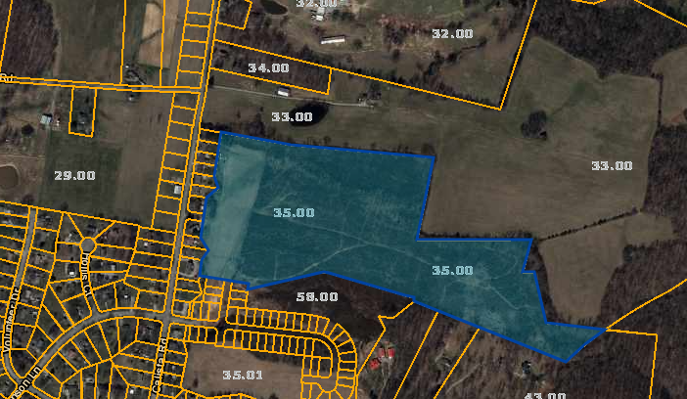

**Item # 4 Staff Notes Parks -Phase 3A:**

Applicant or Representative-Overview: **Bond Reduction:**

**$609,858**

Tax Parcel and ID

**NA**

Zoning

**NCRPUD**

Ordinance Reference and Notes: **3-101.2**

**Project Area Description**

They have received credit for streetlights, asphalt and sidewalk/curb infrastructure.

**Finding of Fact**: Surety Deduction to: $609,858, as Public Works has calculated the new bond amount.

**Staff Overview**

The developer requested a bond reduction in April. Public Services has reviewed and approved the deduction. There are 389 units remaining to be built out of 705.

|  |  |
| --- | --- |
| **ITEM** | **TOTALS** |
| **Street Lights** | **$241,500.00** |
| **Sidewalk / Curb** | **$861,800.00** |
| **Asphalt** | **$343,086.13** |
| **Sewer** | **$0.00** |
| **Stormwater** | **$0.00** |
| **Total** | **$1,446,386.13** |
|  |  |
| **Bond Reduction Completed on 7/8/2022** | |
| **ITEM** | **TOTALS** |
| **Street Lights** | **$77,000.00** |
| **Sidewalk / Curb** | **$287,246.00** |
| **Asphalt** | **$245,612.38** |
| **Sewer** | **$0.00** |
| **Stormwater** | **$0.00** |
| **Total** | **$609,858.38** |

**3-101.2 Surety Instrument**

Moreover, whenever such bond or letter of credit is extended according to these regulations, the price of completing all bondable improvements must be reanalyzed and established by the City Planning Commission in order that the surety instrument be adequate to cover the cost of all improvements.

**Item # 5 Staff:** Requests Recommendation to add Industrial Overlay District to include certain boundaries within I-1, Industrial

**Staff Notes:** The City of White House was identified as a target location by TVA (Tennessee Valley Authority) as a viable economic center. The location has been targeted to attract light manufacturing, corporate headquarter type locations and innovation type industry. The purpose of creating this Industrial Overlay zoning district (I1-O) is to implement the design guidelines and standards of the City of White House Comprehensive Plan. The intent is to permit certain industries which do not detract from:

A. Provide efficient circulation and access;

B. Allow flexibility in siting development, including a range of industrial and

commercial/industrial land uses;

C. Provide visual continuity for streetscapes and developments;

D. Encourage durable, high quality building materials.

The Overlay District is intended to ensure high-quality industrial development with a mix of employment types and uses

**I-1, Light Industrial District Overlay**

A. District Description

This district is designed for a concentration of uses is intended to focus an area for industrial and economic development; however, civic uses are also appropriate. The general development pattern reflects a high level of intensity allowable within the city for industrial, manufacturing, research, and similar type uses. The built environment consists of one- to multi-story buildings and includes both single use and mixed-use activities, including campus-style developments. Street networks and intersections are defined by site and transect context. Cohesive landscaping should be use to soften and minimize the intense economic and industrial activities in this character area. a wide range of industrial and related uses which conform to a high level of performance standards. Industrial establishment of this type, within completely enclosed buildings, provide a buffer between commercial districts and other industrial uses which involve more objectionable influences. New residential development is excluded from this district, both to protect residences from an undesirable environment and to ensure the reservation of adequate areas for industrial development. Community facilities which provide needed services to industrial development are permitted. The area generally includes parcels along the east side of Union Road (north of where Union Road crosses I-65) to Hwy 76. Additionally, the I-O District contains parcels that are in the Industrial Zoning District on the east side of I-65 and parcels on Sage Road that abut residential zoning.

B. Uses Permitted

In the I-1, Light Industrial District, the following uses and their accessory uses are permitted:

1. Food and kindred products manufacturing, except meat products.

2. Textile mill products manufacturing except dying and finishing textiles.

3. Apparel and other finished products made from fabrics, leather, and similar materials manufacturing.

4. Furniture and fixtures manufacturing.

5. Printing, publishing and allied industries.

6. Fabricated metal products manufacturing, except ordinance and accessories.

7. Professional, scientific, and controlling instruments; photographic and optical goods, watch and clock manufacturing.

8. Miscellaneous manufacturing including jewelry, silverware and plated ware, musical instruments and parts, toys, amusement and sporting goods manufacturing, pens, pencils, and other office materials, costume jewelry, novelties and miscellaneous notions; tobacco manufacturing, motion picture production.

9. All types of wholesale trade.

10. Signs and billboards as regulated in Article IV, Section 4.080.

11. Warehouse and storage uses up to 100,000 square feet

12. Agricultural equipment sales and repair.

13. All public utilities including buildings, necessary structures, storage yards and other related uses.

14. Animal health facilities including veterinary clinics.

15. Building materials storage and sales.

16. Retail trade.

17. Professional, financial consulting and administrative services.

18. Communication services.

19. Essential municipal services.

C. Uses Permitted as Special Exception

In the I-1, Light Industrial District, the following uses and their accessory uses may be permitted as special exceptions after review and approval by the Board of Zoning Appeals.

1. Day care centers.

1. Special institutional care facilities. **(Added by Ordinance**

**No. 97-15, December 20, 1997)**

1. Twenty (24) Hour Veterinarian Clinic Accessory Residential

Quarter meeting requirements of 4.160, Excluding Medical

Clinics.  **(Added by Ordinance No. 05-09, May 19, 2005)**

1. Warehouses greater than 100,000 square feet.

D. Uses Prohibited

Uses not specifically permitted or uses not permitted upon approval as a special exception.

E. Dimensional Regulations

All uses permitted in the I-1, Light Industrial District, shall comply with the following requirements except as provided in Article VII, Section 7.020, (Nonconforming Uses).

1. Minimum Lot Size Requirements

No minimum lot size is required in the I-1 District.

2. Minimum Yard Requirements

Front Yard 10 feet

Side Yard 20 feet

Rear Yard 15 feet

Front Building Setback 40 feet

3. Maximum Lot Coverage

On any lot or parcel of land, the area occupied by all buildings including accessory buildings may not exceed fifty (50) percent of the total area of such lot or parcel.

4. Height Requirements

No building shall exceed fifty-three (53) feet in height, **(Amended by Ordinance 15-09, May 21, 2015.)** except as provided in Article VII, Section 7.060.

5. Parking Space Requirements

In addition to the provisions of this ordinance regulating parking spaces and loading areas (Article IV, Section 4.010 and 4.020), the following provisions shall apply to parking and loading areas for uses permitted in this district:

a. All off-street parking lots and loading areas shall be surfaced with dustless, hard surfaced materials such as asphalt or concrete and so constructed to provide for adequate drainage and to prevent the release of dust.

1. Each parking space shall be appropriately marked with painted lines or curbs.
2. Entrances and exits onto and off of a public street shall be paved with a dustless, hard surfaced material for a distance which is at least the equivalent of the required front building setback line measured from the property line at which the access point is located.

6. Landscaping Requirements

Landscape and irrigation plans shall be prepared in accordance with Chapter Article III, Section 3.130.

F. Outdoor Storage

1. All outdoor storage shall take place in the rear half (1/2) of the rear yard and shall be screened by fencing or

landscaping.

2. Outdoor storage is prohibited in the front half (1/2) of the rear yard.

G. Site Design

1. Buildings should be sited to reinforce the public road

network by incorporating façades that give interest to the building wall along the sidewalk, with windows, doors, and other architectural elements approved by Planning Commission.

2. Wherever possible, the main office and visitor entrance

should be oriented toward the street.

3. Visitor entrances to buildings should be clearly visible from a

public street.

4. Buildings should be as close as possible to the front setback

line or immediately behind a landscaped setback area between

the street and the building. Large front setbacks are

discouraged.

Boundary

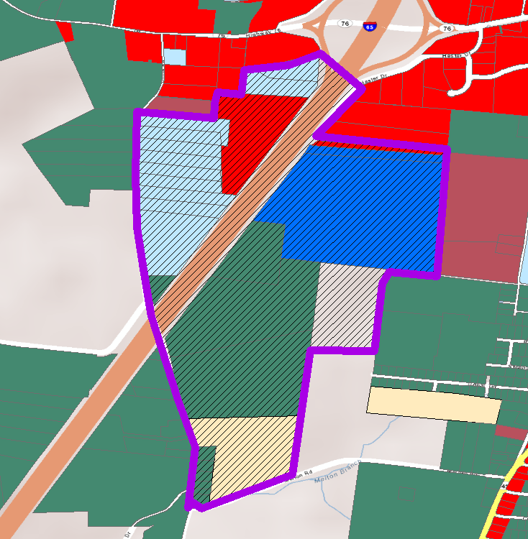

**Staff Findings of Fact: This district provides guidance for light industrial entities looking to develop in this area targeted by TVA.**

**Item # 6 Staff:** Requests Recommendation to the Board of Mayor and Aldermen to amend the Zoning Ordinance to move Article V, Section 5.053.2, C-2, General Commercial, B. #22. “Automobile Sales” from a permitted use to permitted as a special exception after review and approval by the Board of Zoning and Appeals.

Staff Notes: At the June Planning Commission, staff is requested the permitted use for Major Motor Vehicle Service and Repair be moved into special exception. Such uses could include autobody shops. By definition Motor Vehicle Service and Repair, Major-Such use includes, but shall not be limited to establishments involved in engine rebuilding, transmission repair, major reconditioning of worn or damaged motor vehicles or trailers, towing and collision service, including body, frame, or frame straightening or repair, and painting of motor vehicles. This is a request to also move B. #22. “Automobile Sales” from a permitted use to permitted as a special exception, to be consistent with the June request. This will ensure that the site not be an undesirable use in a particular area, as it relates to auto body repair.

**5.053.2 C-2, General Commercial**

A. District Description

This district is designed to provide for certain types of commercial establishments which have a minimum of objectionable characteristics and do not involve storage, transfer or processing of goods or chattels.

B. Uses Permitted

1. Medical offices and clinics.

2. Office buildings for finance, insurance, real estate, legal, engineering, architectural and similar personnel.

3. Hotels and motels.

4. Churches and other places of assembly.

5. Mortuaries and undertaking services.

6. Government buildings and community centers.

7. General retail trade.

8. Entertainment and amusement.

9. Consumer repair.

10. Utility facilities (without storage yards) necessary for the provision of public services.

11. Communication business services.

12. Day Care Centers.

13. Business colleges and other similar educational services (excluding auto-diesel schools).

14. Convenience retail.

15. Apparel and accessories retail.

16. Food service.

17. Auto service stations.

19. Essential municipal services.

20. Interstate Sign District (C-2) (Zoning Atlas, Dated: **(July 10, 1995)**

21. Accessory Firework Sales.

~~22. Automobile sales provided buffer screen is provided and banner and flag streamers are not placed on the property.~~

23. Retail Package Stores

24. Motor Vehicle Service and Repair, Minor

**\*See Article 4, 4.080 Development Standards for Automobile**

**Wrecking, Junk and Salvage Yards and Motor Vehicle Service**

**And Repair, Major and Minor.**

C. Uses Permitted as Special Exceptions

In the C-2, General Commercial District, the following uses and their accessory uses may be permitted as a special exception after review and approval by the Board of Zoning Appeals.

1. Warehousing provided that no manufacturing is involved, screening is provided, and the building does not exceed thirty-five (35) feet in height.

2. Twenty (24) Hour Medical/Veterinarian Clinic Accessory

Residential Quarter meeting requirements of 4.160. **(Added**

**By Ordinance 05-09, May 19, 2005)**

1. Motor Vehicle Service and Repair, Major
2. Automobile sales provided buffer screen is provided and banner and flag streamers are not placed on the property.

D. Uses Prohibited

1. Industrial uses, automobile wrecking, and/or recycling uses, junk or salvage yards, van or truck storage uses and uses not specifically permitted as a special exception. ***(No body shops per Ordinance 92-12)***. **(Amended by Ordinance No. 99-17, July 15, 1999)**

E. Dimensional Regulations

All uses permitted in the C-2, General Commercial District, shall comply with the following requirements except as provided in Article VI.

1. Minimum Lot Size Requirements

No minimum lot size shall be required.

2. Minimum Yard Requirements

Front Yard 20 feet

Two-thirds (2/3) of the front yards

must be dedicated to landscaping).

Side Yard 10 feet

Rear Yard 20 feet

Building Setback 35 feet

3. Maximum Lot Coverage

Provided landscaping and parking requirements are met there is no restrictions on the area occupied by all buildings including accessory buildings on a lot or parcel located in the C-2 District.

4. Height Requirements

No building shall exceed fifty-three (53) feet in height **(Amended by Ordinance 15-09, May 21, 2015.),** except as provided in Article VII, Section 7.060.

F. Landscape Requirements

1. As regulated in Article III, Section 3.130, (c).

G. Outdoor Storage

1. All outdoor storage shall be prohibited in the front yard which shall be interpreted as that portion of the property abutting the right-of-way.

2. Outdoor storage shall take place in the rear yard and shall be screened by solid, non-transparent fencing or landscaping.

**Finding of Fact:** This would add consistency to the zoning ordinance changes made in June in moving major auto repair to be approved by special exception. Auto Dealerships sometimes have major repair as a component of their business unit.

**Item # 7** **Cox’s Place/Gretchen Cox: Annexation R**

**Staff Overview**

The requested annexation is located on Pleasant Grove Rd, just north and adjacent to the Holly Tree Subdivision. This would bring 16 acres into the city, to be owned and subdivided into five lots. When looking at the site plan, the shaded area shown, and the 5.449 acres on the northern edge of the site are what is being requested to be annexed in. The 2.488 acres, immediately off Pleasant Grove Rd will not be a part of this request. This will be a private development, all improvements made to the property will be done to city specifications by owner, including sidewalks, streetlights, road paving and sewer.

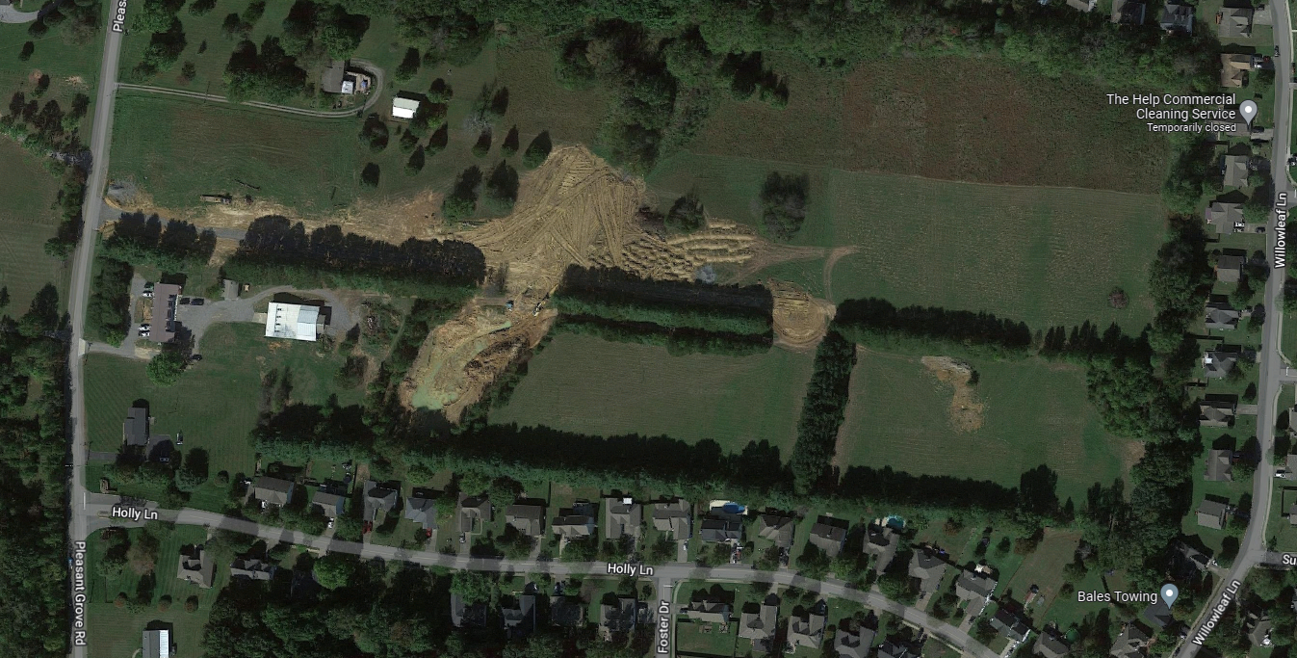

Applicant or Representative-Overview: **Doug Cox**

Tax Parcel and ID

**Robertson County Tax Map 095, Parcel 095.00, 096.00 and 097.00. Property is located at Pleasant Grove Road.**

Zoning and Property

**Robertson County Ag to R-40**

Description Location Overview

**Pleasant Grove Rd**

Comprehensive Plan District:

**Large Lot Residential District**

**Finding of Fact:**

Concurrent with the annexation of additional territory into the City of White House shall be the zoning of that property and the amending of the Official Zoning Map in accordance with the provisions of Article X, of this ordinance. The Planning Commission shall make a recommendation

Staff Recommendation: **Approval to $150,607.98**

**Item # 10 Summerlin-Phase 8:**

Applicant or Representative-Overview: **Tennessee Construction Associates, LLC**

Tax Parcel and ID

**Sumner County Tax Map 077, Parcel 2.00**

Zoning and Property Description Location Overview

**NCRPUD, 5.62 Acres at 3618 Hwy 31W. Located on the west side of Hwy 31W, .15 miles north of the intersection of Calista Rd and Hwy 31W.**

Ordinance Reference and Notes

**Zoning Article 5, 5.056**

Staff Recommendation: **Approval-Site Plan is sufficient and adheres to zoning district requirements.**

**Item # 3 Legacy Farms-Phase 2/Wilson & Associates:**

**Staff Overview**

Requests Final Plat Approval for 32 lots. Summerlin s is located at McCurdy. This development will consist of 299 single family units, with 89 to be built. The only comments to the engineer on this request, was to add the FFE’s to the plat.

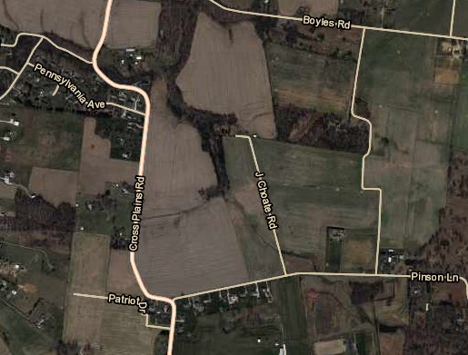

Applicant or Representative-Overview: Goodall Homes

Tax Parcel and ID

**Sumner County Tax Map 96, Parcel 55.01.**

Zoning and Property

SRPUD- **Suburban Residential Planned Unit Development**

Description Location Overview

**Final Plat approval request for 32 lots, phase 8 of Summerlin**

Comprehensive Plan District:

**Residential Single Family Medium Density**

**Finding of Fact:**

The Final Plat matches the Final Master Development Plan

**Item # 11- Copes Crossing Phase 1A**

Applicant or Representative-Overview:

Tax Parcel and ID

**Sumner County Tax Map 77, Parcel 84. Property is**

Zoning and Property

NCRPUD

Description Location Overview

**Final Plat approval request for 7 lots, phase 1A**

Comprehensive Plan District:

**Residential Single Family Medium Density**

**Finding of Fact:**

Staff comments to developer to addFFE’s have been added and the final plat. There were no changes from the approved FDMP. The surety will be calculated and covenants will be reviewed before recording plat.

**Staff Overview**

Requests Final Plat Approval for 7 lots. Copes is located Tyree Springs Rd. This development will consist of 103 Single Family Units. The only comments to the engineer on this request, was to add the FFE’s to the plat.

