**Memo**

To: City of White House Planning Commissioners

From: Ceagus Clark, Director of Planning & Code

Date: 11/4/2021

Re: Cover Page for the Planning Commission meeting scheduled 8/10/2020

**{Public Hearing}**

**Item # 1 Raymond Hirsch Parkway/Kimley Horn:** Requests Recommendation to the Board of Mayor and Aldermen to rezone 17.9 acres from R-20, Low Density Residential to NCRPUD,

Owner: Patricia and Austin Jones

**Item # 2 Patel Convenience Store/GreenLID Design:** Requests Site Plan Approval for a 4,000 square foot convenience store with gas pumps. Property is zoned C-2, General Commercial

Owner: Shrihari LLC

**~~Item # 3 David P. Wilkes/Bruce Rainey & Associates:~~** ~~Requests Site Plan Approval~~

**Item # 4 White House Apartment Complex/MB Civil Engineering:** Requests Final Master Plan Approval for a 216-unit multi-family residential development on approximately 11.36 acres..

Owner: RFM Development Co.

**{Public Hearing}**

**Item # 5 Drew Christenson:** Requests Recommendation to the Board of Mayor and Aldermen to rezone 1.6 acres from R-10, High Density Residential to C-6, Town Center Commercial District.

**Item # 6 Scooter’s Coffee/Carter Engineering:** Requests Site Plan Approval for a 664 square foot drive-thru only coffee kiosk. Property is zoned C-2, General Commercial

Owner: James Benson

615-672-4350 Ext 2119

Ceagus Clark

Director, Planning and Codes

**Item # 1 Raymond Hirsch Parkway/Kimley Horn:**

**Staff Overview**

This is a proposed townhome development on Raymond Hirsch, just west of Hwy 31W, with 142 townhomes. The developer presented this project at a study session in September. Details of this PDMP will have connections to the greenway, amenities featuring a dog park, pocket parks a swimming pool and a club house (labeled an amenity building). There will be a south bound left turn lane into the development. The roads are designed to city specification and are intended to be dedicated public roadways. This development shows a connection to a potential development adjacent to its site. The developer will be prepared to discuss changes to the elevations shown in the packet. Staff made additional comments to the developer regarding sidewalks at the perimeter of the property along Raymond Hircsh.

Planning Comments to Developer –

**Comment 1**: Ensure access on Raymond Hirsch does not cause access issue for any potential access on portion of property on opposite side of state highway if they plan to develop it soon.

*Response 1: The location of the proposed access drive along Raymond Hirsch allows opposing driveway on the remaining property to be located directly across the roadway to create a 4-way intersection. Alternatively, access could be provided further east on the remaining property with adequate spacing such that two separate T-intersections could operate with relatively low crash potential, or shared access could be pursued with the adjacent shopping center*.

**Comment 2:** Ensure stormwater quality measures are planned appropriately as stormwater areas

are labeled as detention only.

*Response 2: Acknowledged. Stormwater quality measures will be included in the drainage*

design. Stormwater area labels updated on “C2-00 – SITE LAYOUT – OVERALL”.

**Comment 3:** Color elevations, lighting, and landscape plan.

*Response 3: These items have been added to sheets A1-00, E1-00, and L1-00, respectively.*

**Applicant or Representative-Overview:** Patricia and Austin Jones

Tax Parcel and ID

Robertson County Tax Map 107I, Parcel 77

**Zoning**

**R-20 to NCRPUD**

Ordinance Reference and Notes:

**Project Area Description**

17.9 acres, 142 townhome units located on the north side of Raymond Hirsch

**Staff Recommendation:**

This PDMP meets the criteria for approving the rezoning to NCRPUD. It is within the Town Center, where direction has been given to allow for the higher density projects. This is located in the White House Crossroads district in the comprehensive plan.

**Item # 1 Raymond Hirsch Parkway/Kimley Horn:**

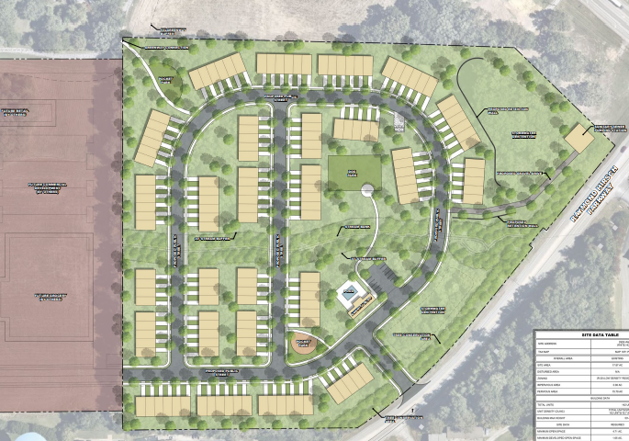

**5.056 PLANNED DEVELOPMENT DISTRICTS**

**5.056.1 DISTRICT DESCRIPTION**

To provide maximum flexibility in the application and implementation of design standards within areas specifically designated by an adopted Community Master Plan. This district is created with the intent of achieving a scale and form of development that emphasizes sensitivity to pedestrian movement, minimizes intrusion of the automobile into new streets and roads, and provides for the sensitive placement of open spaces in relation to building masses, street design and accessories, and landscaping features in a manner otherwise not insured by the application of conventional developments and standards. The village concept combines a mixture of compatible uses including single-family, semi-detached, townhouse and neighborhood commercial and office areas. This shall be blended in a compact, walkable layout with landscaped streets, a network of sidewalks, open space that preserves the natural features of the land and provides the necessary public and community facilities.

**Item # 1 Raymond Hirsch Parkway/Kimley Horn:**

This district shall create a traditional type of development that nurtures diversity in social and economic backgrounds while enhancing aesthetics and maintaining a small town character.

**5.056.5 Residential Planned Developments**

**The Planning Commission may vary this design where creative site and building**

**design are proposed.**

A. Type of Developments

There are hereby created two (2) types of residential PUDs as follows:

Suburban Residential Planned Development SRPUD

Neighborhood Center Residential Planned Development NCRPUD

B. Purpose

The purpose of a SRPUD is to permit development of land, which by reason of topography or floodable land contains some areas unsuitable for development, and to permit the cluster of lots in order to leave the unsuitable land as permanent open space.

The purpose of a NCRPUD is to permit a variety of housing types within a totally planned environment.

C. Minimum Size

The minimum size of either residential PUD shall be five (5) acres. The planning commission and board of mayor and aldermen may, within their discretion, approve developments considered as an infill on less acreage.

D. Permitted Activities in a Residential PUD

The activities listed in Table I listed as “may be considered a permitted use” in a RPUD only when deemed appropriate by the Planning Commission and the Board of Mayor and Aldermen as approved with the preliminary master plan. Other activities listed as prohibited in Table 1 or not listed in Table 1 below are prohibited.

Residential accessory residential dwelling units shall require review by the Board of Zoning Appeals for a special exception under Section 4.190 of this ordinance. If a residential planned unit development is being designed to include accessory dwelling units for the entire development, then such units will need to be included on the preliminary master plan to be approved by Planning Commission and Board of Mayor and Aldermen. **(Added by Ordinance 06-31, August 17, 2006)**

**Item # 1 Raymond Hirsch Parkway/Kimley Horn:**

E. Limitation on Commercial Activities

The commercial activities permitted in Table I, shall be limited to no more than four (4) percent of the total floor area within such development and provided further that the maximum floor area for any establishment shall be five thousand (5,000) square feet. Such commercial activities shall be designed to serve primarily the residents within the PUD and shall not be constructed until at least one-half (1/2) the residential units are complete. Home occupations shall be considered separate from convenience commercial and shall be regulated under article 4.180. **(Amended by Ordinance 06-16, May 18, 2006)**

**Item # 1 Raymond Hirsch Parkway/Kimley Horn:**

**Table I**

**Permitted Uses and Structures**

**Residential Planned Development**

Residential Activities Districts

Permanent Residential SRPUD NCRPUD

Dwelling Attached N P

Dwelling One-Family Detached P P

Dwelling Two-Family Detached P N

Dwelling Semi-Detached P P

Dwelling Mobile Home N N

Dwelling Multi-Family N P

Residential Accessory Dwelling Unit (section 4.190) SE SE

Semi-Permanent Residential N N

Community Facilities Activities

Administrative Services P P

Community Assembly P P

Community Education P P

Cultural & Recreation Services P P

Essential Services P P

Personal & Group Care Facilities N P

Religious Facilities P P

Commercial Activities

Consumer Repair Services P P

Convenience Commercial P P*

Home Occupations (Section 4.180) P P

Entertainment & Amusement Services P* P

Financial, Consultative &Administrative P P

Food & Beverage Services P* P

General Business Services P* P

General Personal Services P* P

Medical and Professional Services P P

Key to Interpreting Uses

P - May be considered as a permitted use.

N - Not permitted in the district.

SE- May be considered by Board of Zoning Appeals as Special Exception

* May be considered only when the PUD contains 200 units or more.

**Item # 1 Raymond Hirsch Parkway/Kimley Horn:**

G. Neighborhood Center Residential Planned Development

1. Density, Bulk and Open Space Regulations for One Family Detached Dwellings

a. Density and Open Space Regulations

Maximum Density 6.0 Units/Acre

Minimum Lot Size 4,500 sq. ft. *

Maximum Density Minimum Open Space %

2.5 to 3.0 Units/Acre 20 %

3.0 to 4.0 Units/Acre 25 %

4.0 to 6.0 Units/Acre 30 %

A minimum 100-foot setback where a residential collector intersects a major collector shall be observed. This requirement may be waived for innovative/alternative designs.

The remaining area shall be left as common open space and used for designated purposes as approved by the Planning Commission. A minimum of five (5) percent of the site shall be improved recreational open space.

2. Yards

Minimum Front Yard 35 ft.

Minimum Side Yard 6.5* ft. or zero lot line

Minimum Rear Yard 6.5*ft.

*\*Five-feet side (5) minimum side setback permitted where*

*fire protection meets City’s Fire Department requirements*

*for reduced building separation.*

A twenty-five (25) foot building setback consisting of dedicated open space is required around the outside boundary of the development.

1. Density, Bulk and Open Space Regulations for Multi-Family Dwellings

a. Density, Bulk and Open Space Regulations

The following requirements shall apply to multi-family dwellings within a high-density residential planned development:

Maximum Area per Dwelling Unit 3,000 Sq. Ft.

Minimum Required Open Space 30 percent

Minimum Developed Open Space 10 percent

Maximum Building Height 53 Feet

b. The maximum overall densities shall be in terms of the number of dwelling units per gross acre of all the area within said development.

**Item # 1 Raymond Hirsch Parkway/Kimley Horn:**

c. The maximum floor area shall be in terms of a ratio of total floor area per total area within said development, as provided herein.

d. Yard requirements are waived and the above minimum controls shall be applied with the following exception a twenty-five (25) foot building setback consisting of dedicated open space is required around the outside boundary of the development.

e. The minimum total outdoor area (including all uncovered outdoor areas, such as streets, parking, lawn, landscaped areas, patios, recreation, as well as usable roofs and uncovered balconies) shall be provided at no less than a minimum ratio of outdoor area per total floor area, as provided herein.

f. The minimum total living space (that part of the total outdoor area which includes lawn, landscaping, and recreation areas and excluding streets and parking) shall be provided at no less than a minimum ratio of living space area per total floor area, as provided

H. Limitation on Density

The planning commission and board of mayor and aldermen may, within their discretion, limit the density to a figure lower than the maximum permitted above. This type of limitation shall be exercised only if the character of the adjoining neighborhood is inappropriate for the proposed development or if the development would place an excessive burden on the existing street and utility system.

**Item # 2 Patel Convenience Store/****GreenLID Design**

**Applicant or Representative-Overview:**

GreenLID Design

**Tax Parcel and ID**

Robertson County Tax Map 117K, Group A, Parcel 004.00

(lots 4,5 and 6)

**Zoning**

C-2

**Project Area Description**

Southwest corner of Business Park Drive and Hwy 31W

**Staff Recommendation:**

Deferral. The application is missing elevations for the 4,000 Square foot convenience store.

**Staff Overview**

This is a proposed fuel station and 4,000 square foot convenience store located on the southwest corner of Business Park Drive and Hwy 31W. The site will have two access points, from both Business Park and 31W. Staff has reviewed site plans and corresponded with the engineer. All staff comments have been satisfied except the lack of elevations.

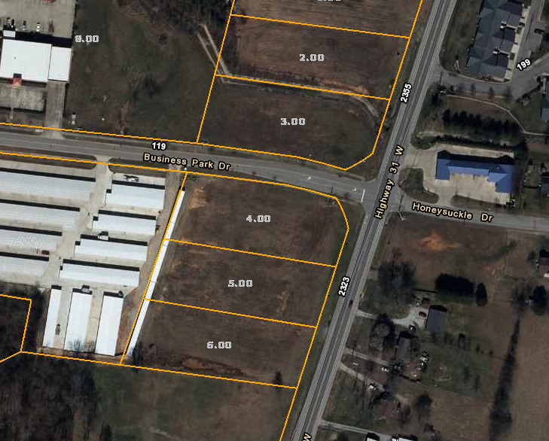

**Item # 2 Patel Convenience Store/GreenLID Design**

Patel site

* Provide revision/measures to grading plan to reduce runoff leaving the site untreated thru the access driveway
* Reveal how building downspouts tie stormwater into this site surface
* Site plan must have the dimensions shown for all accesses, the tdot sheet/details must be included with site plan approval to ensure the city and tdot have the exact equal information for development plans (grading permit may not be provided until TDOT permit issued)
* Provide building elevations
* Ensure parallel parking stalls are long enough
* Reveal truck access is sufficient around rear of building given parking stall locations and tight radii (check vs standard delivery trucks and city fire apparatus)
* Show loading/unloading zone planned
* If traffic is one way around building add signage, if twoway increase lane widths
* Protect building corners with bollards/curb/grass strip ???
* Provide space for rear building access to remain out of drive aisle upon exiting building
* Offsite sidewalks must be connected to interior sidewalks
* City regulation is runoff reduction at 80%, reveal design calculations for the water treatment in accordance with metro BMP design criteria---LID spreadsheet is step one, but other calcs must be revealed for sizing and flows
* I understand the overall site design and pond precedes this site, however, we cannot approve an increase in stormwater quantity flows....reduce to below existing conditions or route to the stormwater pond if possible (we can look at this further with the engineer to consider possible solutions)  if city planning has prior design calculations available, this would help determine the appropriate/possible solutions considering the business park

Response

1. Grading plan revisions have been provided to prevent runoff from leaving the site untreated.

2. Downspouts will be detailed on architectural elevations.

3. The TDOT plan will be provided when approved. After approval, a revised site layout will be

submitted to the City if changes are made.

4. Building elevations will be provided when received.

5. Parallel spaces have been removed.

6. Truck access sheet has been provided in a separate attachment.

7. Loading/unloading zone will be labeled after reviewing architecture.

**Item # 2 Patel Convenience Store/GreenLID Design**

8. Traffic direction has been clarified.

9. Bollards have been provided at the building corners.

10. Offsite sidewalk connection has been provided.

11. In addition to the LID spreadsheet detailing runoff reduction, HydroCAD, weir and pipe calculations

have been provided.

12. Building elevations will be provided when received.

13. Drive aisle direction arrows have been provided.

14. Dumpster pad screening will meet city standards.

15. Pump layout has been revised to better accommodate stacking space.

16. TDOT plans will be provided upon approval.

17. Sidewalks have been provided.

18. Agreed.

**Item # 2 Patel Convenience Store/GreenLID Design**

**5.053.2 C-2, General Commercial**

A. District Description

This district is designed to provide for certain types of commercial establishments which have a minimum of objectionable characteristics and do not involve storage, transfer or processing of goods or chattels.

B. Uses Permitted

1. Medical offices and clinics.

2. Office buildings for finance, insurance, real estate, legal, engineering, architectural and similar personnel.

3. Hotels and motels.

4. Churches and other places of assembly.

5. Mortuaries and undertaking services.

6. Government buildings and community centers.

7. General retail trade.

8. Entertainment and amusement.

9. Consumer repair.

10. Utility facilities (without storage yards) necessary for the provision of public services.

11. Communication business services.

12. Day Care Centers.

13. Business colleges and other similar educational services (excluding auto-diesel schools).

14. Convenience retail.

15. Apparel and accessories retail.

16. Food service.

17. Auto service stations.

18. Animal care and veterinary.

19. Essential municipal services.

20. Interstate Sign District (C-2) (Zoning Atlas, Dated: **(July 10, 1995)**

21. Accessory Firework Sales.

22. Automobile sales provided buffer screen is provided and banner and flag streamers are not placed on the property.

23. Retail Package Stores

24. Motor Vehicle Service and Repair, Minor

25. Motor Vehicle Service and Repair, Major

**\*See Article 4, 4.080 Development Standards for Automobile**

**Wrecking, Junk and Salvage Yards and Motor Vehicle Service**

**And Repair, Major and Minor.**

C. Uses Permitted as Special Exceptions

In the C-2, General Commercial District, the following uses and their accessory uses may be permitted as a special exception after review and approval by the Board of Zoning Appeals.

1. Warehousing provided that no manufacturing is involved, screening is provided, and the building does not exceed thirty-five (35) feet in height.

2. Twenty (24) Hour Medical/Veterinarian Clinic Accessory

Residential Quarter meeting requirements of 4.160. **(Added**

**By Ordinance 05-09, May 19, 2005)**

D. Uses Prohibited

1. Industrial uses, automobile wrecking, and/or recycling uses, junk or salvage yards, van or truck storage uses and uses not specifically permitted as a special exception. ***(No body shops per Ordinance 92-12)***. **(Amended by Ordinance No. 99-17, July 15, 1999)**

E. Dimensional Regulations

All uses permitted in the C-2, General Commercial District, shall comply with the following requirements except as provided in Article VI.

1. Minimum Lot Size Requirements

No minimum lot size shall be required.

2. Minimum Yard Requirements

Front Yard 20 feet

Two-thirds (2/3) of the front yards

must be dedicated to landscaping).

Side Yard 10 feet

Rear Yard 20 feet

Building Setback 35 feet

3. Maximum Lot Coverage

Provided landscaping and parking requirements are met there is no restrictions on the area occupied by all buildings including accessory buildings on a lot or parcel located in the C-2 District.

4. Height Requirements

No building shall exceed fifty-three (53) feet in height **(Amended by Ordinance 15-09, May 21, 2015.),** except as provided in Article VII, Section 7.060.

F. Landscape Requirements

1. As regulated in Article III, Section 3.130, (c).

G. Outdoor Storage

1. All outdoor storage shall be prohibited in the front yard which shall be interpreted as that portion of the property abutting the right-of-way.

2. Outdoor storage shall take place in the rear yard and shall be screened by solid, non-transparent fencing or landscaping.

**Item # 4 White House Apartment Complex/MB Civil Engineering:**

**Staff Overview**

The applicant is requesting preliminary plat approval. The property was rezoned to RTC and C-6 back in 2018. The preliminary plan was approved in May 2021. The proposed site is located in the city’s town center at Hwy 76 and Hwy 31W, behind Mapco and Advanced Auto. The site will be a mix of multi and single-family homes. There will be two access points into the development, from both 76 and 31W. There will be 216 multifamily. The developer has decided not to do the single family and use that as open space abutting the single family homes on Hilwood. The following pages describe RTC and C-6 Zoning and the description of the Town Center within the

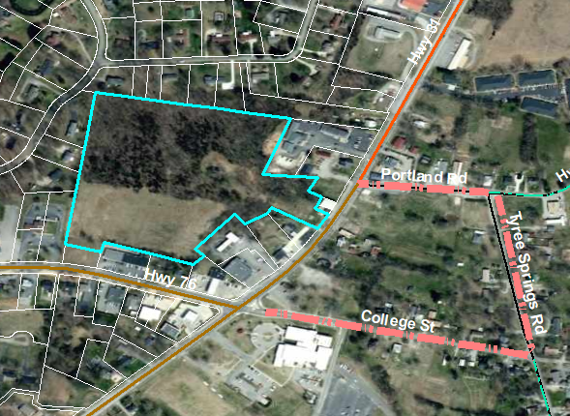

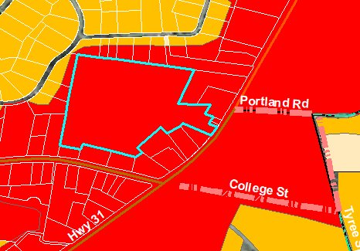

**Applicant or Representative-Overview:** MB Civil Engineering

**Tax Parcel and ID**

Robertson County Tax Map 107G, Group A, Parcel 37.00

**Zoning-** C-6

**Project Area Description**

Total site is 16 acres. 11.36 will be used for the development of multifamily, with one commercial lot on Hwy 76.

**Staff Recommendation:**

Approval. Staff has reviewed plans. The developer has addressed staff comments.

**Reference Item #4 Exotic Marble & Granite**

This site should be referenced to the purple section of the map, known as Innovation. The description is below the map.

**Reference Item #4 Exotic Marble & Granite**

**5.054.1 I-1, Light Industrial District**

**Item # 4 White House Apartment Complex/MB Civil Engineering:**

**Subject: Whitehouse Apartments for RFM Development city comments and responses 10-14-21**

Responses in RED

1. Realign site access from the easts to be near 90 degrees where entrance hits the parking lot area. See revised site plan.
2. Reduce parking stalls to a maximum of 12 contiguous spaces. This has been corrected. See revised site plan.
3. Provide property or easement inclusion of the accesses on both sides. The property will remain as one tract. The rear portion outside the Detention area will remain undeveloped.
4. Provide property or easement connection of all required stormwater areas (looks as if one pond is on separate parcel, tract, etc.) See comment above regarding one parcel.
5. Ensure solid waste facilities are sized appropriately as more details for sizing will be required during site plan review. From similar facilities that RFM has done on average the complex produces around 61 lbs per month per unit. This number was derived from average tonnage picked up by waste management each month and divided by the number of units per complex. The complex will have Valet trash service that picks up trash Daily Sunday-Thursday at each unit. The valet service monitors the compactor and when the pressure gauge reaches 80%, the complex calls for a pickup from Waste Management. On average similar complexes need 1 pickup a month. This system has led to the complexes never having an issue with trash capacity at the facility.
6. Reveal mail access facilities- Kiosk. The Mail kiosk is inside the clubhouse and has been labeled.
7. Review traffic study warrant for site access from Hwy 76 right turn lane going eastbound onto Driveway B. The TIS indicates that a left turn lane is needed from HWY 76 with 50’ of storage. This would be for the eastbound lane. It does not mention a right turn lane.
8. Provide pedestrian sidewalk on the SR76 entry heading into the clubhouse. This has been provided, see revised site plan.

**Item # 4 White House Apartment Complex/MB Civil Engineering:**

**Existing Zoning:** Zoning is the process of dividing land in a municipality into zones or districts in which certain land uses are permitted or prohibited. Zoning regulations are a land use regulatory tool for local governments meant to protect the general welfare of a community by establishing minimum development standards. The City of White House has eighteen different zones classified within its City limits per Article V of the Zoning Ordinance; however, not all of these districts are mapped on the City’s Zoning Map. As the Zoning Map shows, below, most of the zones within the City are residential. These range from a Large Lot District (R-40) to a High-Density District (R10). Commercial Districts, established by the Zoning Ordinance, include a range of commercial intensities from a Central Business District to a neighbor service district, to a general commercial district. These commercial districts are concentrated along the Interstate 65/SR 76 Interchange and the main thoroughfares throughout the City. Commercial districts are meant to be located in appropriate proximity to established residential areas and near major transportation connections, such as Interstate 65, offering local and regional retail and service trades to residents and the traveling public. The City’s Zoning Ordinance incorporates both residential and commercial Planned Unit Development (PUD) districts, as well.

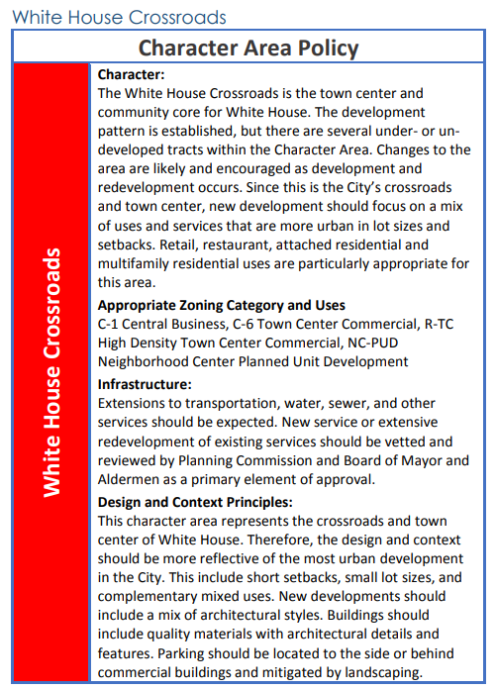

**I Item # 4 White House Apartment Complex/MB Civil Engineering:**

**5.053.6 C-6,Town Center Commercial District**

1. District Description: This district is designed to provide for a mixed use

Commercial, office, and residential zoning district for the redevelopment of the City’s Town Center including retail, office service uses with high performance standards, community facilities, and high density residential uses. The regulations are structured to permit maximum freedom of pedestrian traffic. A relatively high intensity of use is permitted in this district.

1. Permitted Uses: In the C-6 Town Center Commercial District, the following

Uses and their accessory uses as described are permitted by right.

Community Facility Activities:

Cultural and Recreational Services

Essential Municipal Services

Commercial Activities:

Convenience Commercial. Drive thru lanes, open bays, and accessory uses shall not be visible from roadways and be located at the rear of buildings. Indoor Entertainment and Amusement Services, with the exception of adult entertainment uses as defined in zoning ordinance.

Financial, Consulting, and Administrative Services. Drive thru lanes, and accessory uses shall not be visible from roadways and be located at the rear of buildings.

Food and Beverage Services

Consumer Repair Services, not including vehicle and mechanical repair services.

General Business and Communication Services

General Personal Services

General Retail Trade

Medical and Professional Services

Hotels

Mixed Use Facility with Permitted Residential Activities

Other uses determined by Planning Commission that are compatible with town center uses but shall not include prohibited uses.

Retail Package Stores

Residential Activities:

Multi-Family Residential at density of 20 units per acre, or 50 units per acre if the residential units are housed in buildings of at least 4 stories and a minimum of 40 feet tall. Properties with limited lot area shall be permitted one residential unit per 750 sq ft of building area designated for multi-family use.

Mixed Use Facility with Permitted Commercial Activities including upper story residential uses.

1. Uses Permitted as Special Exceptions:

**Item # 4 White House Apartment Complex/MB Civil Engineering:**

In the C-6, Town Center Commercial District, the following uses and their accessory uses may be permitted as special exceptions after review and approval in accordance with the provisions of the Zoning Ordinance.

Detached Single Family Residential Dwelling

Accessory Residential Family Dwelling Unit

Education and Day Care Facilities

Churches and Places of Community Assembly

Health Care Facilities

1. Prohibited Uses:

Industrial uses, automobile wrecking, recycling uses (except city recycling drop-off center), junk or salvage yards, van, car, or truck storage uses, body shops and other types of vehicular repair uses, automotive, marine, trailer, and farm implement sales uses, distribution, warehousing, and construction uses, all types of rental storage uses, as well as any type use requiring outdoor storage, as well as any other uses not otherwise permitted. Seasonal and permanent sales of fireworks. Other uses determined by the Planning Commission to be non-compatible with town center uses.

1. Dimensional Regulations:

Minimum Lot Size 1,000 sq ft

Lot Width at Building Setback 20 ft minimum

Maximum Lot Coverage 100%

Maximum Building Height 53 ft.

Minimum Building Height 25 ft

Front Setback Minimum None/7.5 ft Maximum

* + - Only courtyards and landscaping are permitted in front setbacks.

Side Yard Setback Minimum None/10 ft Maximum

Rear Yard Setback 5 ft Minimum on Interior Roadways and

Alleyways/20 ft Minimum for Perimeter

Zoning Boundary

**Special Conditions:**

Building setback shall be listed on approved final subdivision plat. The

Subdivision plat shall include five (5) ft building construction and

maintenance easement. Due to building connections and reduced

building setbacks then exterior walls shall be designed to meet provisions

of City’s adopted building and fire codes. The Planning Commission in

review of the site plan and subdivision plats for all developments,

including single family dwellings, may alter minimum lot size, lot width,

and setback requirements due to the unique development characteristics

with a mixed use town center redevelopment project.

1. Other Provisions:

**Item # 5 Drew Christenson: Rezoning**

Applicant or Representative-Overview:

Tax Parcel and ID

Zoning

Project Area Description

Staff Recommendation:

Approval, this request is within the scope of the comprehensive plan, as it the requested rezoning lot is in the White House Crossroads district, and adjacent property is zoned C-6

**Staff Overview**

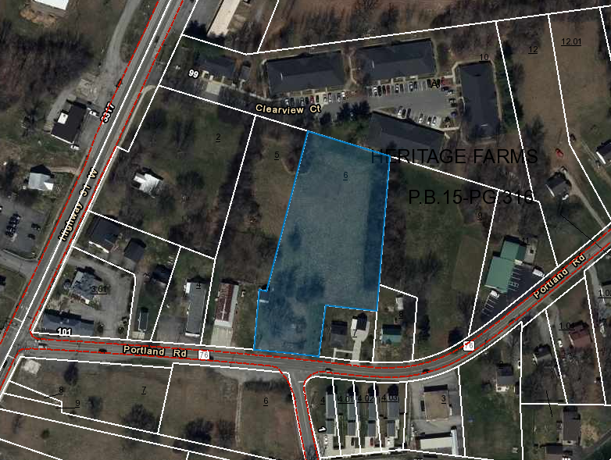

The proposed location for this zoning request is located at Tyree Springs and Portland Rd, located on the north side of Portland Rd. The property owner is requesting a rezoning from R-10 to C-6. There is a concept plan showing t

he intent of building 12 single family lots. This site is within the town center, and is between two C-6 zoned parcels.

**Item # 5 Drew Christenson: Rezoning**

**5.052.4 R-10, High Density Residential District**

A. District Description

This district is designed to provide suitable areas for high density residential development where sufficient urban facilities are available or where such facilities will be available prior to development wherever possible. Most generally this district will be characterized by residential structures each containing a multiple number of dwelling units. However, it is the intent of this ordinance to not restrict in number the dwelling units contained in a building provided there is sufficient area of zone lot and open space on such lot relative to the number of dwelling units thereon. This district is intended also to permit community facility and public utility installations which are necessary to service and do service specifically the residents of the district, or those installations which are benefited by and compatible with a residential environment.

B. Uses Permitted

In the R-10, High Density Residential District, the following uses and their accessory uses are permitted.

1. Multi-family dwellings. Must meet requirements per Development Standards for Multi-Family Projects, Section 5.056.1, I, (8).

2. Duplex dwellings. Must meet requirements per Development Standards for Attached Dwellings, Section 5.056.1, l, (9).

3. Mobile home parks as regulated in Article IV, Section 4.100.

4. Customary accessory buildings, including private garages and non-commercial workshops meeting the requirements of Section 3.100 Accessory Use Regulations.

5. Customary incidental home occupations as regulated in, Section 4.180.

6. Essential municipal services.

7. Single family detached dwellings.

C. Uses Permitted as Special Exceptions

In the R-10, High Density Residential District, the following uses and their accessory uses may be permitted as special exceptions after review and approval by the Board of Zoning Appeals.

1. Churches.

2. Public and private schools offering general education courses.

**Item # 5 Drew Christenson: Rezoning**

3. Day Care Centers. **(Amended by Ordinance 06-08, Feb. 16, 2006)**

4. Pubic and semi-public recreational facilities and grounds.

5. Utility facilities (without storage yards) necessary for the provisions of public services.

6. Government buildings and community centers.

7. Cemeteries.

8. Bed and Breakfast Home Residences and Short-Term Rentals-Owner Occupied. (See Article IV, Section 4.100, Special Conditions for Review Pertaining to Bed and Breakfast Home Residences). **(Added by Ordinance No. 96-7, April 18, 1996.)**

D. Uses Prohibited

Billboards and similar advertising structures; uses not specifically permitted; or uses not permitted upon approval as a special exception.

E. Dimensional Regulations

All uses permitted in the R-10, High Density Residential District shall comply with the following requirements except as provided in Article IV, Section 4.100, Mobile Home Parks.

1. Minimum Lot Size - 10,000 square feet

Area Per/Dwelling Unit

Duplex Dwelling - 5,000 square feet/dwelling unit

Multi-Family Dwelling - 3,333 square feet/dwelling unit

Single Family Dwelling 10,000 square feet/dwelling unit

Lot Width at Building Setback Line - 75 feet

2. Minimum Yard Requirements

Front Setback 35 feet

Side 10 feet

Rear 20 feet

3. Maximum Lot Coverage

On any lot or parcel of land, the area occupied by all buildings including accessory buildings may not exceed seventy (70) percent of the total area of such lot or parcel.

**Item # 5 Drew Christenson: Rezoning**

4. Height Requirements

No building shall exceed thirty-five (35) feet in height, except as provided in Article VII, Section 7.060. (With a Special Exception Available to up to 53 feet) **Amended by Ordinance**

**15-09, May 21, 2015.)**

5. Parking Space Requirements

As regulated in Article IV, Section 4.010.

6. Landscape Requirements

For multi-family developments, see Article III, Section 3.120.

**Item # 6 Staff:** **Requests Cancellation of the adopted development for Calista Farms**

**Item # 5 Drew Christenson: Rezoning**

**5.053.6 C-6,Town Center Commercial District**

1. District Description: This district is designed to provide for a mixed use

Commercial, office, and residential zoning district for the redevelopment of the City’s Town Center including retail, office service uses with high performance standards, community facilities, and high density residential uses. The regulations are structured to permit maximum freedom of pedestrian traffic. A relatively high intensity of use is permitted in this district.

1. Permitted Uses: In the C-6 Town Center Commercial District, the following

Uses and their accessory uses as described are permitted by right.

Community Facility Activities:

Cultural and Recreational Services

Essential Municipal Services

Commercial Activities:

Convenience Commercial. Drive thru lanes, open bays, and accessory uses shall not be visible from roadways and be located at the rear of buildings. Indoor Entertainment and Amusement Services, with the exception of adult entertainment uses as defined in zoning ordinance.

Financial, Consulting, and Administrative Services. Drive thru lanes, and accessory uses shall not be visible from roadways and be located at the rear of buildings.

Food and Beverage Services

Consumer Repair Services, not including vehicle and mechanical repair services.

General Business and Communication Services

General Personal Services

General Retail Trade

Medical and Professional Services

Hotels

Mixed Use Facility with Permitted Residential Activities

Other uses determined by Planning Commission that are compatible with town center uses but shall not include prohibited uses.

Retail Package Stores

Residential Activities:

Multi-Family Residential at density of 20 units per acre, or 50 units per acre if the residential units are housed in buildings of at least 4 stories and a minimum of 40 feet tall. Properties with limited lot area shall be permitted one residential unit per 750 sq ft of building area designated for multi-family use.

Mixed Use Facility with Permitted Commercial Activities including upper story residential uses.

1. Uses Permitted as Special Exceptions:

**Item # 5 Drew Christenson: Rezoning**

In the C-6, Town Center Commercial District, the following uses and their accessory uses may be permitted as special exceptions after review and approval in accordance with the provisions of the Zoning Ordinance.

Detached Single Family Residential Dwelling

Accessory Residential Family Dwelling Unit

Education and Day Care Facilities

Churches and Places of Community Assembly

Health Care Facilities

Short-Term Rentals (4.100)

1. Prohibited Uses:

Industrial uses, automobile wrecking, recycling uses (except city recycling drop-off center), junk or salvage yards, van, car, or truck storage uses, body shops and other types of vehicular repair uses, automotive, marine, trailer, and farm implement sales uses, distribution, warehousing, and construction uses, all types of rental storage uses, as well as any type use requiring outdoor storage, as well as any other uses not otherwise permitted. Seasonal and permanent sales of fireworks. Other uses determined by the Planning Commission to be non-compatible with town center uses.

1. Dimensional Regulations:

Minimum Lot Size 1,000 sq ft

Lot Width at Building Setback 20 ft minimum

Maximum Lot Coverage 100%

Maximum Building Height 53 ft.

Minimum Building Height 25 ft

Front Setback Minimum None/7.5 ft Maximum

* + - Only courtyards and landscaping are permitted in front setbacks.

Side Yard Setback Minimum None/10 ft Maximum

Rear Yard Setback 5 ft Minimum on Interior Roadways and

Alleyways/20 ft Minimum for Perimeter

Zoning Boundary

**Special Conditions:**

Building setback shall be listed on approved final subdivision plat. The

Subdivision plat shall include five (5) ft building construction and

maintenance easement. Due to building connections and reduced

building setbacks then exterior walls shall be designed to meet provisions

of City’s adopted building and fire codes. The Planning Commission in

review of the site plan and subdivision plats for all developments,

including single family dwellings, may alter minimum lot size, lot width,

and setback requirements due to the unique development characteristics

with a mixed use town center redevelopment project.

1. Other Provisions:
2. **Item # 5 Drew Christenson: Rezoning**

Accessory Structures

Accessory structures may be located in rear yards only at the discretion of the Planning Commission on an approved site plan.

Parking Requirements

The number, size, and construction of parking spaces shall be regulated per zoning ordinance requirements and commercial design standards. Parking areas shall be located to rear of buildings to promote a continuous street-wall. On-street parking and shared parking facilities are encouraged.

Service Areas

The delivery, service, mechanical and electrical units, and dumpster/trash cart area shall be located at rear of site and shall not be visible from roadways.

**Item # 6 Scooter’s Coffee/Carter Engineering:**

**Item # 6 Scooter’s Coffee/Carter Engineering:**

**Staff Overview**

This is a proposed request to approve a site plan of Scooter’s Coffee, to be located on an out-lot in the Dollar General Market shopping center. Scooter’s will be a coffee kiosk, with drive-thru service. The site plan has been reviewed by staff. The below rendering will be similar to the proposed site.

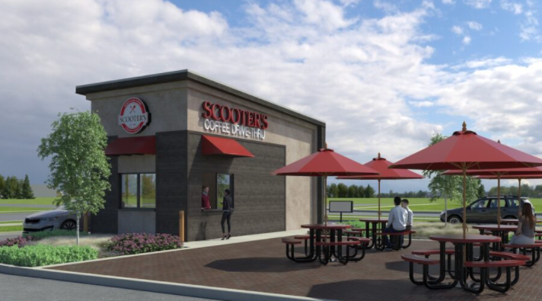

**Staff Comments.** Scooter’s Coffee

* Make sure dumpster enclosure complies with City of White House design standards
* At the area where the Proposed Menu Board (behind) we’d like to see landscaped seating area, with railing separating drive lane.
* Drainage/sewer comments will come at preconstruction meeting.
* Responses are due 10/27, given the delay in me providing my comments.

**Applicant or Representative-Overview:**

Carter Engineering

**Tax Parcel and ID**

Robertson County Tax Map 107I, Group B, Parcel 079.00

**Zoning**

C-2

**Staff Recommendation:** **Approval, site plan has been reviewed by staff.**

**Item # 6 Scooter’s Coffee/Carter Engineering** 