**Memo**

To: City of White House Planning Commissioners

From: Ceagus Clark, Director of Planning & Code

Date: 10/6/2021

Re: Cover Page for the Planning Commission meeting scheduled 10/12/2021

**Item # 1 Item # 1 Cambria-Phase 3A:**

**Item # 2 Beech Grove Development/Jeremy Leggo:**

**Item # 3** **Sage Road Residential Development/Klober Engineering:Item # 4** **Calista Farms:**

**Item # 5 Staff:** Text Amendment, Definition of Commercial Amusement Services, Commercial Amusement Performance Standards for Campgrounds

**~~Item # 6 Staff:~~** ~~Comprehensive Plan amendment~~ I will bring this in November.

**Item # 7 Staff Discussion:** Vocational Construction Use for Site on Union Rd.

Please review September 13, 2021 packet for originally submitted information regarding the three deferred projects.

Give me a call or email if you have questions regarding the staff notes.

615-616-1019

Ceagus Clark

Director, Planning and Code

**Item # 1 Staff Notes- Cambria Phase 3A**

Applicant or Representative-Overview:

**Current Bond Amount $76,405**

Tax Parcel and ID

**NA**

Zoning

**R-15**

Ordinance Reference and Notes: **3-101.2**

Project Area Description

**Cambria Development Phase 3A-Montelana Dr**

Staff Recommendation: **Approval of bond extension of 6% to $80,989**

**Staff Overview**

Cambria Phase 3A has 9 lots. The plat was recorded in 2019. Construction plans for phase 3B has recently been completed.

Work left to be done:

**Montelena Drive**

3,350 square feet of Sidewalk **-$50,976**

Extruded curb asphalt repair, pavement striping- **$30,013**

**Total: $80,989**

**3-101.2 Surety Instrument**

Moreover, whenever such bond or letter of credit is extended according to these regulations, the price of completing all bondable improvements must be reanalyzed and established by the City Planning Commission in order that the surety instrument be adequate to cover the cost of all improvements.

**Item # 2 Item # 2** **Beech Grove Development/Jeremy Leggo:**

**Staff Overview**

This was an already approved project for 70 townhomes to NCRPUD. The developer has purchased the five-acre lot adjacent and requesting to rezone this parcel to NCRPUD with an additional 48 townhomes, but will also add an additional 11,000 square feet of retail space in the front of the development. There is a condemned old real estate office that currently sits on the property.

There will be turn lanes into the development at both access points, but a southbound turn lane should be considered.

Other stipulations to be included are to make the show the sidewalks going through the driveways.

Adhere to 35’ setbacks.

This was deferred from the September 13th meeting with stipulations that the developer address:

* drainage concerns,
* list of amenities
* add different materials to breakup exterior elevation-such as cultured stone, brick, board and batten, etc.
* Show loop around back of 14-units for fire truck turn-around.

The Developer Responded to the above stipulations showing

* **Addition of a color illustrative plan**
* **Addition of a dog park**
* **Moved pavilion to larger open space behind the units and added additional pedestrian network**
* **Removal of the playground in favor of lawn area**
* **Reworked layout of units in NE corner to provide better vehicular and emergency vehicle circulation**
* **Addition of transitional buffer yards based on adjoining zoning**
* **Addition of a second mail kiosk**
* **Addition of a note indicating minimum driveway lengths to support parking**
* **Depiction of monument sign locations**
* **Reduction of townhome unit count to 118**

Applicant or Representative-Overview: **Jeremy Leggo**

Tax Parcel and ID

**Sumner County Tax Map 97, Parcel 009.00**

Zoning

**C-2 to NCRPUD**

Ordinance Reference and Notes: **2724 Highway 31W.**

Project Area Description

**Hwy 31 Corridor**

Staff Recommendation:

**Approval** with stipulations based on the updated plan submittal.

Sidewalks shown thru driveways.

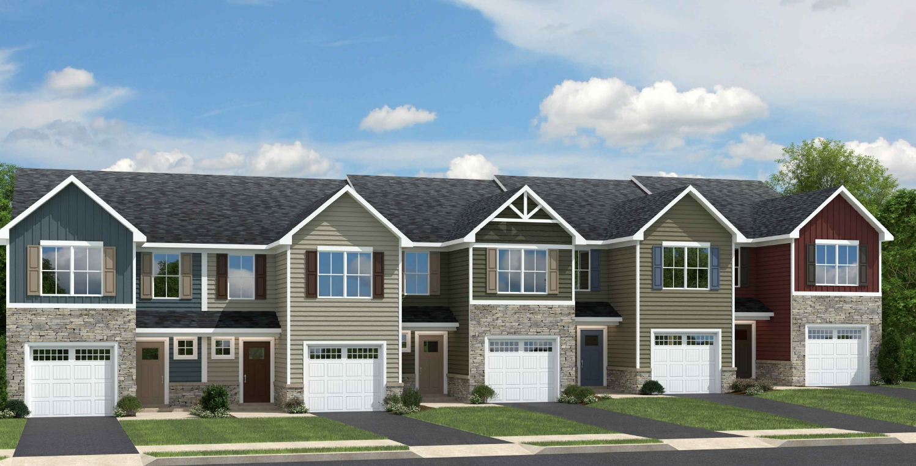**Updated Elevations Beech Grove Development/Jeremy Leggo:**

**Item # 3 Sage Road Residential Development/Klober Engineering:**

**Staff Overview**

This is a request for the development of 57 acres located on Sage Road. This property was rezoned from I-1 to NCRPUD. The approved plan consisted of 80 single family homes and 46 town homes (126 total units). This project would be 143 Single Family homes, and 96 multifamily units (40 apartments and 56 townhomes). The following stipulations were requested from the Planning Commissioners for this deferred agenda item.

1.Show different drive location due to concern as shown which would

create more traffic through Hampton Village,

2. List of amenities

3.Show buffer width between development and Orchard Park-leave

existing tree buffer

4.Show exterior elevations-for homes, townhomes, and apartments-brick,

Stone/,Hardi-Board type materials, etc.

5. Show 35 ft. setbacks for driveways.

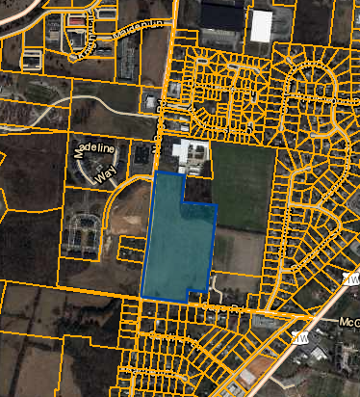

Applicant or Representative-Overview: **Klober Engineering**

Tax Parcel and ID

**Robertson County Tax Map 106, Part of Parcels 193, and 16.**

Zoning and Property

**NCRPUD**

Description Location Overview

**Sage Road**

Comprehensive Plan District:

**Mixed-Use**

Staff Recommendation:

Approval, PDMP has been revised to show the entrance to Sage moved further north. The multifamily has been located to the southwest corner near Sage/Cardinal. The additional stipulations have been addressed on the plan.

**Sage Road Residential Development Elevations**

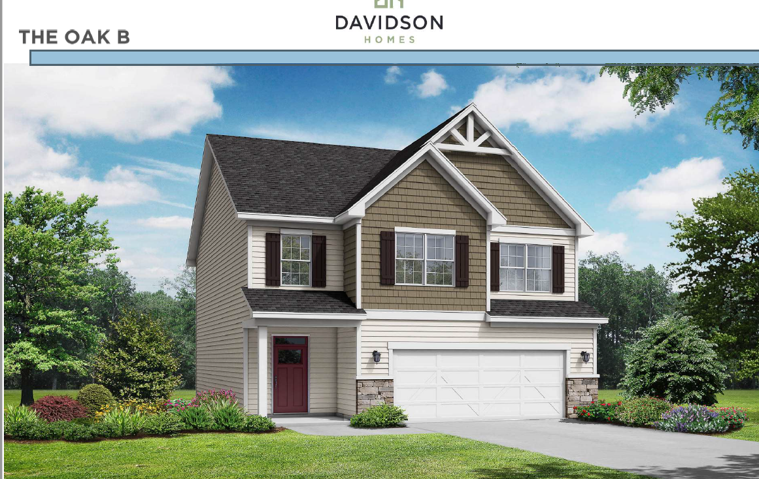

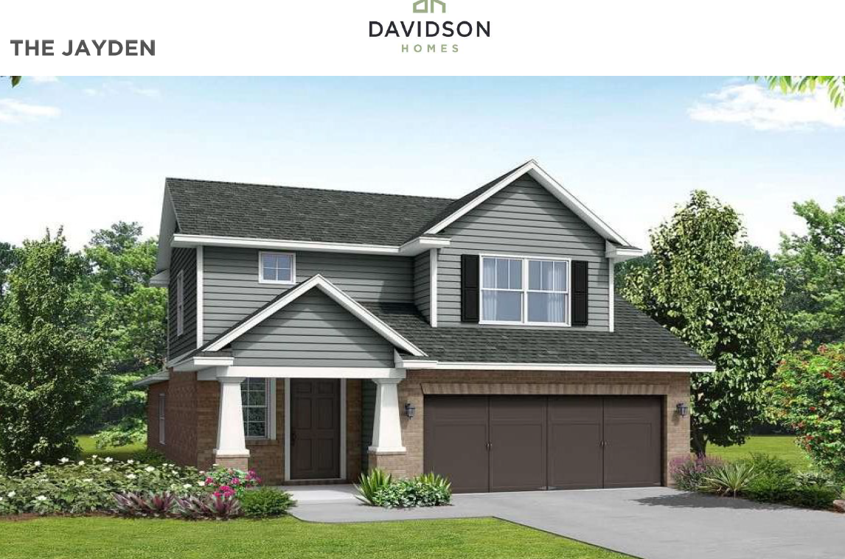

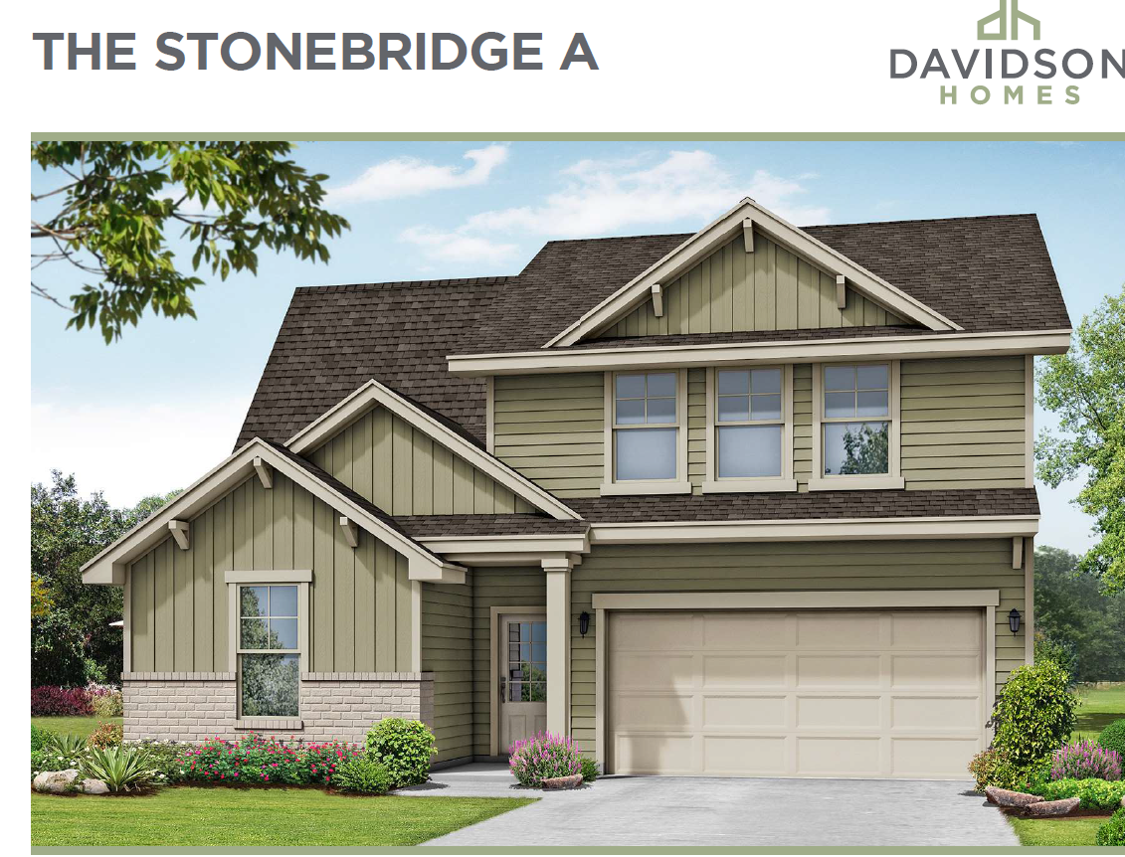

**Item # 4** **Calista Farms: Klober Engineering**

Applicant or Representative-Overview: **Sam Lamberth**

Tax Parcel and ID

**Robertson County Tax Map 096, Parcels 32 and 33. Property is located at Calista Road**

Zoning and Property

**R-15 to SRPUD**

Description Location Overview

**Calista Rd.**

Comprehensive Plan District:

**Single Family Medium Density**

Staff Recommendation:

Approval

Staff Recommendation: **Approval to $150,607.98**

**Staff Overview**

**Staff Overview**

Please see packet from September 13 meeting. I did not include them in this packet as there were no changes made.

The applicant is requesting to annex in 34.6 acres and rezone an existing 93 acres to SRPUD. This land was previously zoned NCRPUD for Calista Farms. The former plan consisted of 401 units (201 townhomes and 200 SF) The proposal is for 305 units at 2.4 units per acres. The site plan outlines amenities and has connections to the surrounding subdivisions.

This item was deferred for more clarity on elevations and traffic concerns on Calista Rd.

After discussions on road improvements, the developer agreed to contribute $500,000 in cash in addition to impact fees to be paid.

A timeline for improvements to be made has been set at three years.

By the recording of phase 1, the developer will pay cash to the city.

The Calista Rd improvements will adhere to the roadway design guidelines for arterial roads in three phases:

* Wilkinson to Bill Moss
* Indian Ridge to Wilkinson Lane
* Bill Moss to Concord Springs (city limits boundary)

**See the above elevations under Sage Rd development. The elevations will be similar, per the developer.**



**Item # 5 Staff:** Text Amendment

Staff Note: Zoning Districts have permitted use for Commercial Amusement Services, but there is not definition. I have also included the addition of performance standards for campgrounds.

***2.020 Definitions***

***Commercial Amusement Services, Indoor. A facility providing for indoor recreational activities, services, amusements, and instruction, usually for an admission fee. Uses may include, but are not limited to, bowling alleys, ice or roller-skating rinks, bingo parlors, amusement arcades, or practice areas.***

***Commercial Amusement Services, Outdoor. A facility providing for outdoor recreational activities, services, amusements, and instruction for an admission fee, including, but not limited to, batting cages, miniature golf, go-kart tracks, commercial campgrounds, commercial recreation sports, racetracks (motorcycle, auto, dog).***

***4.201 Development Standards for Campgrounds  
  
When an application for a group assembly permit includes a private campground, the following standards shall be  
met:  
(A) Such campground shall have on-site management;  
(B) The campground may include convenience commercial establishments such as camp stores, laundry facilities, and personal services; provided that such convenience establishments are subordinate to the recreational character of the campground; are located, designed, and intended to serve exclusively the patrons staying in the campground; and such establishments and their parking areas shall not occupy more than ten percent  
  
(10%) of the area of the park or one (1) acre whichever is smaller;  
(C) Such campground shall meet the following  
standards:  
(1) Minimum size - ten (10) acres  
(2) Maximum density - ten (10) campsites  
per gross acre  
(3) Sanitary facilities, including flush toilets and showers - within three hundred feet (300') walking distance of each campsite  
(4) Portable water supply - one (1) spigot for each four (4) campsites  
(5) Trash receptacle - one (1) for each two (2) campsites  
(6) Parking - one (1) space per campsite (7) Picnic table - one (1) per campsite  
(8) Fireplace or grill - one (1) per campsite (9) Administration or safety building - open  
at all times wherein a portable fire extinguisher in operable condition and first aid kit is available, and a telephone is available for public use.  
(D) Such campground shall meet the following  
design requirements:  
(1) A vegetation screen or ornamental fence  
which will substantially screen the campsites from view of public rights-of-way and neighboring properties shall be provided around or near the perimeter or that part of the campground containing campsites. Such vegetation or fence shall be maintained in good condition at all times.  
(2) Each campground shall reserve at least twenty-five percent (25%) of its total area as natural open space excluding perimeter screening. Such open space may include recreation and water areas, but may not include utility areas, administration buildings, commercial areas or similar activities.  
(3) Each campsite shall have a minimum setback of twenty-five feet (25') from any exterior boundary line.  
(4) Each campsite and all other buildings shall have a minimum setback from any public road of fifty feet (50').  
(5) Each separate campsite shall contain a minimum of three thousand two hundred (3,200)  
square feet. (A campsite shall be considered to consist of trailer or tent space, parking space, picnic table, fireplace, and one-half (1/2) the road-way providing access.)  
(6) Each campsite shall be directly accessible by an interior road.  
(7) All interior roads shall be a minimum of ten feet (10') wide for one way traffic and eighteen feet (18') wide for two way traffic.  
(8) All interior roads shall meet the following curve requirements:  
Minimum radius for a 90 degrees turn - 40 feet Minimum radius for a 60 degrees turn - 50 feet Minimum radius for a 45 degrees turn - 68 feet  
(9) No camping vehicle or camping equipment shall be used for human habitation for a period exceeding thirty (30) consecutive days.  
(10) Each campground shall provide a trailer dump station for the disposal of holding tanks***

***(11) All parking and driving surface will be required to be paved to City of White House parking lot and roadway design specifications (See City of White House Subdivision Regulations)***

**Staff Recommendation:** Approval

City of White House Municipal/Regional Planning Commission

**BYLAWS AND RULES OF PROCEDURE**

**Meeting Information:** The name of the Planning Commission shall be the City of White House Municipal-Regional Planning Commission.

**Meeting Dates:** The Planning Commission shall meet the second Monday of the Month at 7 pm in the Billy S. Hobbs Municipal Building, unless another date is designated on the annually approved Planning Commission Meeting Calendar and Plan Submittal Requirements. Special called meetings and study sessions may be held as determined by Planning Commission and Secretary. All meetings shall be open to the public; however, not all meetings are public hearing. On agenda items not requiring a public hearing, Comments and testimony from the general public on any issue may be heard at the opinion of the Commission

**Meeting Notice:** Notice of regular meetings, as to the time and place of the meetings, shall be advertised annually in a newspaper of general circulation in the White House area during January of each calendar year. Special called meetings and study sessions shall be advertised in local newspaper of general circulation in the White House area seven (7) days prior to the meeting.

**Manner of Voting.** The voting on all questions coming before the Commission shall be by voice vote or, if requested by a Commission member, by hand count. The “ayes” and the “nays” shall be entered upon the minutes of such meeting except that when the vote of all Commissioners present is unanimous the record of such unanimous vote shall be sufficient. Each motion or action of the Planning Commission shall include specific findings of fact and statements of material evidence and include the reasons for its actions. The action taken on the motion and the specific findings and reasons shall be noted in the minutes of such meeting. On all consent and regular agenda items the Commission shall either vote to approve, deny, or defer an item a maximum of one meeting. Upon request of the item applicant an item may be deferred more than one month. All approvals with stipulations shall include the stipulations in the meeting minutes. On rezoning and comprehensive plan amendments, or other agenda items determined by the Planning Commission the public hearing and discussion may occur prior to the Commission’s vote on the agenda item.

**Conflict of Interest** Any member who considers their personal interest involved in any manner before the Commission shall make a disclosure of such interest and be excused from voting on such matter.

**Quorum.** A majority of the membership of the White House Municipal-Regional Planning Commission shall constitute a quorum for the purpose of conducting the business of the Commission. Approval of any business shall be by a favorable vote of a majority of the Planning Commission members in attendance

**Records:** The records of the Planning Commission shall be kept in City Hall and be available to the public during all normal business hours.

**Membership**. The membership of the White House Municipal-Regional Planning Commission shall conform to T.C.A. § 13-3-101 and 13-4-101 An official roster of Planning Commission members shall be kept by the Secretary of the Commission. At least one (1) member, but not more than two (2), shall be from the planning region. Members shall file an annual conflict of interest disclosure form. The Members shall obtain four (4) hours of training for planning related topics either as provided by the City of White House or self-study.

**Order of Business:** A. Member roll call

1. Review and approval of previous meeting minutes,
2. Review and approval of agenda
3. Review and approval of consent agenda items
4. Review and approval of regular agenda items
5. Other Business including member and staff reports and discussion items if applicable.
6. Adjournment

**Agenda:** The Secretary shall provide an agenda including consent and regular agenda items and a staff recommendation letter on all agenda items. The Commission at the end of consent and regular agenda may choose to include Other Business items including member and staff reports, discussion items, or training items. The annually approved Planning Commission Meeting Calendar and Plan Submittal Requirements shall include all plan submittal requirements.

**Agenda Item Review:**

A. Property information

B. Project type, building square footage, number of lots, applicant, etc.

C. Public Hearing (Rezoning and Comprehensive Plan Amendments)

D. Staff reports

E. Professional statements and reports

F. Staff recommendations

G. Plan submittals

H. Review photos or other site specific information presented at the meeting

I. Traffic, drainage, or other site design or specific issues based on plan submittal or site visits.

J. Planning Commission discussion

K. Discussion Recap and Statement of facts and material evidence.

L. Motion:

- Basis of approval or denial including reference to agenda review items, stipulations, and issues.

**Rezoning Requests Review Criteria:**

After the advertised public hearing, the Commission shall review the following items and any additional items:

a. Comprehensive Plan area designation

b. Existing and adjacent property uses

c. Future uses of area

d. Permitted uses in the proposed zoning district.

e. Major changes in the area created by public building projects, economic development, roadway and utility improvements, or other changes that are determined to necessitate a zoning change recommendation or denial.

**Comprehensive Plan Amendment Criteria:**

After the advertised public hearing, the Commission shall review the following review and any additional review items for a Comprehensive Plan amendment when an agenda item is not consistent with the Comprehensive Plan:

a. Changes in area due to infrastructure and utility improvements

b. Changes due to City, County, State or Federal roadway, utility, or building projects.

c. Changes in area since comprehensive plan adopted that are determined to be positive growth

d. Changes in the area due to large scale economic development projects

e. Other changes determined to based on planning principals.

**Officers.** The officers of the Commission shall be a Chairman, a Vice- Chairman.

**Elections.** The Chairman, Vice-Chairman and shall be elected at the July meeting of the Planning Commission. Election of Vice-Chairman and Secretary shall follow the same procedure as that of the Chairman. All elected officers of the Commission shall serve for a term of one (1) year and shall be eligible for re-election.

**Chairman.**  The Chairman shall preside at all meetings of the Commission and shall perform such other duties as the Commission shall authorize. The Chairman shall exercise their voice and vote as a member of the Commission.

**Vice-Chairman.**  In the absence of the Chairman, the Vice- Chairman shall perform the duties of the Chairman.

**Secretary.** The Secretary shall be the Planning/Codes Director. The secretary shall responsible for maintaining a full record of all proceedings for the commission and the minutes. The Secretary shall also perform such other duties in regard to records, including the certification of plats, and record transcripts, as the Commission may direct.

**Vacancies.** Should the office of Chairman and Vice-Chairman become vacant the Commission shall elect successors to these positions to serve for the unexpired term of said offices

**Amending Rules**. These rules may be amended by a majority of the members of the Commission and may be proposed at any regular or special meeting of the Commission, by presentation of written copies of the proposal to the members present.

**Waiving or Suspending Rules.** A rule of procedure may be suspended or waived at any meeting by majority vote of Commission members present.